1. What is Angular?
Angular is a TypeScript-based front-end web application framework. It targets both the browser and the server. Angular is one of the most popular frameworks for UI design today, with hundreds of thousands of developers worldwide contributing to its community project. Its compelling features and performance have made it an essential tool for any web developer to have in their toolbox. It is maintained by Google, and its primary function is to design single-page applications. Angular has significant advantages as a framework, while also providing a common architecture for developers to work with. It allows developers to create large, maintainable applications.

2. Why were client-side frameworks like Angular introduced?
Back in the day, web developers used VanillaJS and jQuery to develop dynamic websites but, as the logic of one's website grew, the code became more and more tedious to maintain. For applications that use complex logic, developers had to put in extra effort to maintain the separation of concerns for the app. Also, jQuery did not provide facilities for data handling across views.
For tackling the above problems, client-side frameworks like Angular came into the picture, which made life easier for the developers by handling the separation of concerns and dividing code into smaller bits of information (In the case of Angular, called Components).
Client-side frameworks allow one to develop advanced web applications like Single-Page-Application. Not that we cannot develop SPAs using VanillaJS, but by doing so, the development process becomes slower.

3. How does an Angular application work?
Every Angular app consists of a file named angular.json. This file will contain all the configurations of the app. While building the app, the builder looks at this file to find the entry point of the application. Following is an image of the angular.json file:
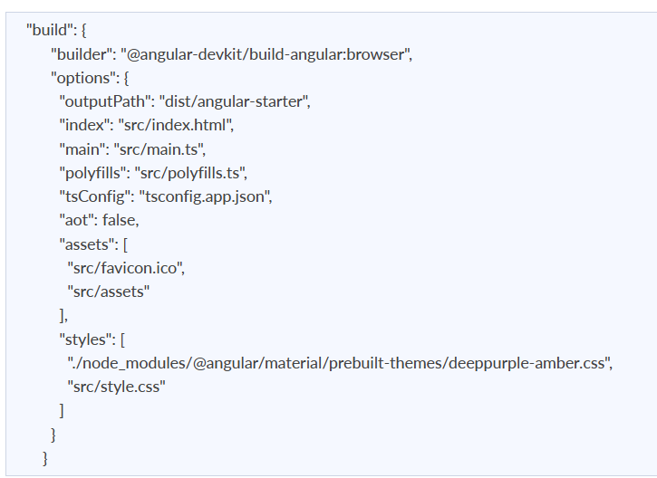
Inside the build section, the main property of the options object defines the entry point of the application which in this case is main.ts.
The main.ts file creates a browser environment for the application to run, and, along with this, it also calls a function called bootstrapModule, which bootstraps the application. These two steps are performed in the following order inside the main.ts file:
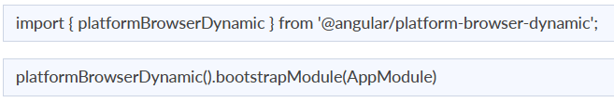
In the above line of code, AppModule is getting bootstrapped.
The AppModule is declared in the app.module.ts file. This module contains declarations of all the components.
Below is an example of app.module.ts file:
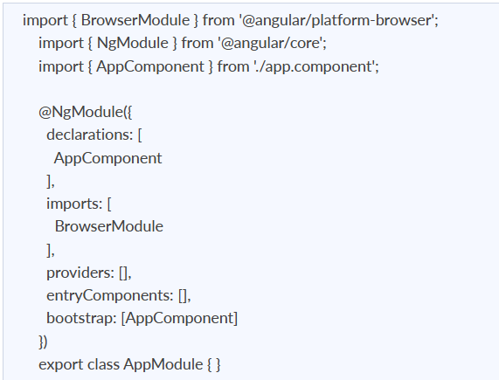
As one can see in the above file, AppComponent is getting bootstrapped.
This component is defined in app.component.ts file. This file interacts with the webpage and serves data to it.
Below is an example of app.component.ts file:
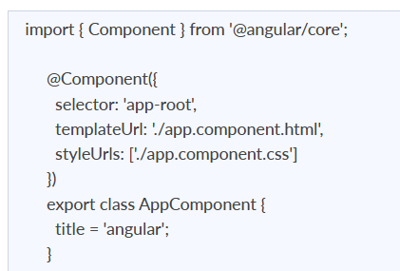
Each component is declared with three properties:
- Selector - used for accessing the component
- Template/TemplateURL - contains HTML of the component
- StylesURL - contains component-specific stylesheets
After this, Angular calls the index.html file. This file consequently calls the root component that is app-root. The root component is defined in app.component.ts. This is how the index.html file looks:
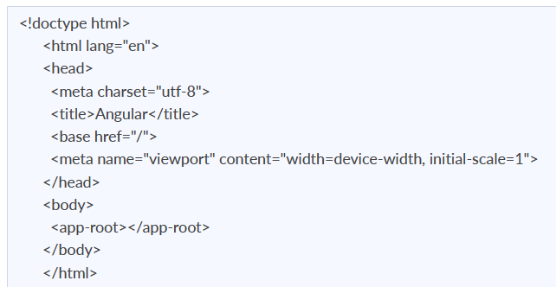
The HTML template of the root component is displayed inside the <app-root> tags.
This is how every angular application works.

4. What are some of the advantages of Angular over other frameworks?
- Features that are provided out of the box - Angular provides a number of built-in features like routing, state management, rxjs library and http servicesstraight out of the box. This means that one does not need to look for the above-stated features separately. They are all provided with angular.
- Declarative UI - Angular uses HTML to render the UI of an application. HTML is a declarative language and is much easier to use than JavaScript.
- Long-term Google support - Google announced Long-term support for Angular. This means that Google plans to stick with Angular and further scale up its ecosystem.

5. What are the advantages of Angular over React?
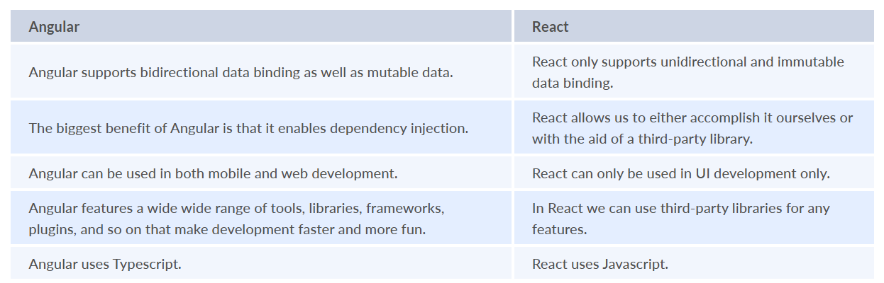

6. List out differences between AngularJS and Angular?
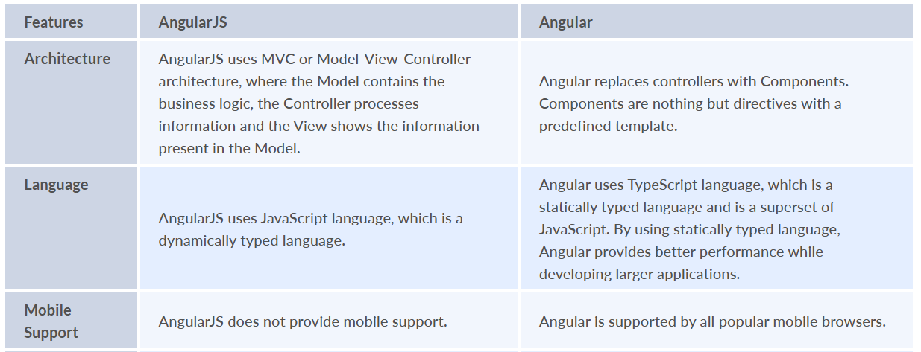
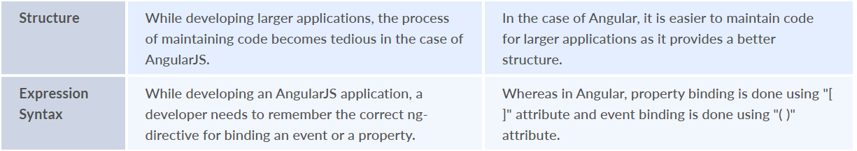

7. How are Angular expressions different from JavaScript expressions?
The first and perhaps, the biggest difference is that Angular expressions allow us to write JavaScript in HTML which is not the case when it comes to JavaScript expressions.
Next, Angular expressions are evaluated against a local scope object whereas JavaScript expressions are against a global window object. Let's understand that better with an example :
Consider the following component named test:
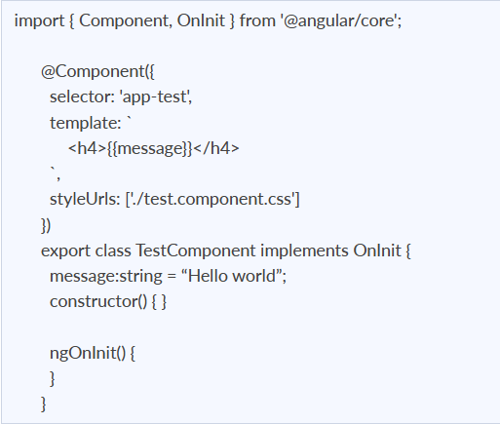
As one can see that Angular expression is used to display the message property of a component. Since we are using Angular expressions, in the present template, we cannot access a property outside of its local scope, which in this case is TestComponent.
This proves that Angular expressions are always evaluated based on the scope object rather than the global object.
The next difference is how Angular expressions handle null and undefined.
Consider the following JavaScript example:
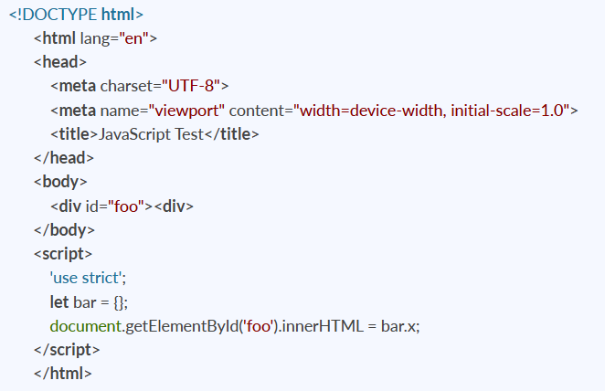
If you run the above code, you will see undefined displayed on the screen. Although it’s not ideal to leave any property undefined, the user does not need to see this.
Now consider the following Angular example:
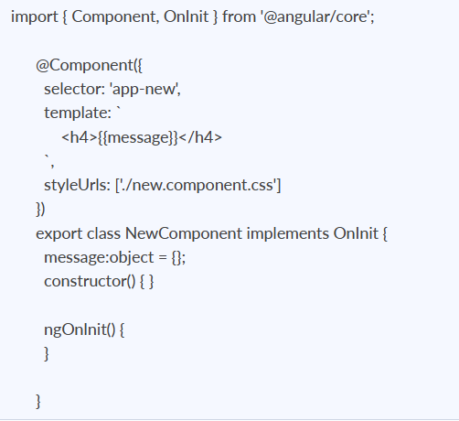
If you render the above component, you will not see undefined being displayed on the screen.
Next, in Angular expressions, one cannot use loops, conditionals and exceptions.
The difference which makes Angular expressions quite beneficial is the use of pipes. Angular uses pipes(called filters in AngularJS), which can be used to format data before displaying it. Let’s see one predefined pipe in action:
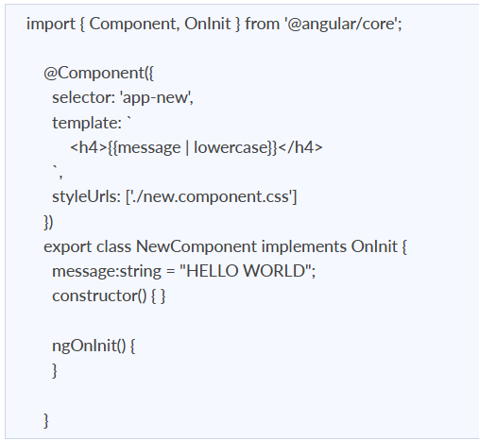
In the above code, we have used a predefined pipe called lowercase, which transforms all the letters in lowercase. Therefore, if you render the above component, you will see “hello world” being displayed.
In contrast, JavaScript does not have the concept of pipes.

8. What are Single Page Applications (SPA)?
Single page applications are web based applications that only need to be loaded once, with new functionality consisting of only minor changes to the user interface. It does not load new HTML pages to display the content of the new page, but rather generates it dynamically. This is made feasible by JavaScript's ability to alter DOM components on the current page. A Single Page Application method is speedier, resulting in a more consistent user experience.

9. What are templates in Angular?
A template is a kind of HTML that instructs Angular about how to display a component. An Angular HTML template, like conventional HTML, produces a view, or user interface, in the browser, but with far more capabilities. Angular API evaluates an HTML template of a component, creates HTML, and renders it.
There are two ways to create a template in an Angular component:
- Inline Template
- Linked Template
Inline Template: The component decorator's template config is used to specify an inline HTML template for a component. The Template will be wrapped inside the single or double quotes.
Example:
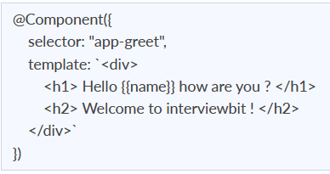
Linked Template: A component may include an HTML template in a separate HTML file. As illustrated below, the templateUrl option is used to indicate the path of the HTML template file.
Example:
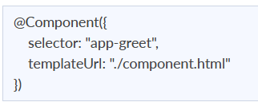

10. What are directives in Angular?
A directive is a class in Angular that is declared with a @Directive decorator.
Every directive has its own behaviour and can be imported into various components of an application.
When to use a directive?
Consider an application, where multiple components need to have similar functionalities. The norm thing to do is by adding this functionality individually to every component but, this task is tedious to perform. In such a situation, one can create a directive having the required functionality and then, import the directive to components which require this functionality.
Types of directives:
1. Component directives
These form the main class in directives. Instead of @Directive decorator we use @Component decorator to declare these directives. These directives have a view, a stylesheet and a selector property.
2. Structural directives
- These directives are generally used to manipulate DOM elements.
- Every structural directive has a ‘ * ’ sign before them.
- We can apply these directives to any DOM element.
Let’s see some built-in structural directives in action:
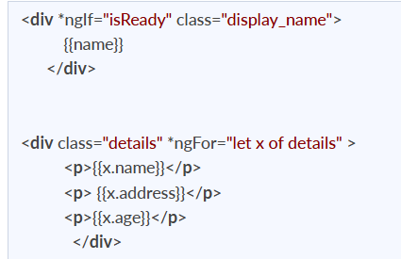
In the above example, we can *ngIf and *ngFor directives being used.
*ngIf is used to check a boolean value and if it’s truthy,the div element will be displayed.
*ngFor is used to iterate over a list and display each item of the list.
3. Attribute Directives
These directives are used to change the look and behaviour of a DOM element. Let’s understand attribute directives by creating one:
How to create a custom directive?
We’re going to create an attribute directive:
In the command terminal, navigate to the directory of the angular app and type the following command to generate a directive: ng g directive blueBackground
The following directive will be generated. Manipulate the directive to look like this:
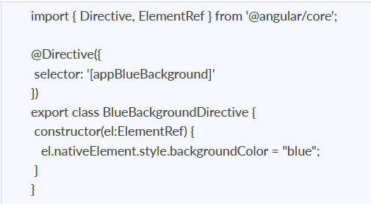
Now we can apply the above directive to any DOM element: <p appBlueBackground>Hello World!</p>

11. Explain Components, Modules and Services in Angular
For better understanding, I would like you to create an Angular application by running the following inside the command terminal: ng new angularApp
The above command will create an angular application in the directory.
Next, let's move on to understand Components, Modules, and Services.
- Components
In Angular, components are the basic building blocks, which control a part of the UI for any application.
A component is defined using the @Component decorator. Every component consists of three parts, the template which loads the view for the component, a stylesheet which defines the look and feel for the component, and a class that contains the business logic for the component.
For creating a component, inside the command terminal, navigate to the directory of the application created, and run the following command: ng generate component testOr ng g c test
One can see the generated component inside src/app/test folder. The component will be defined inside test.component.ts and this is how it looks:
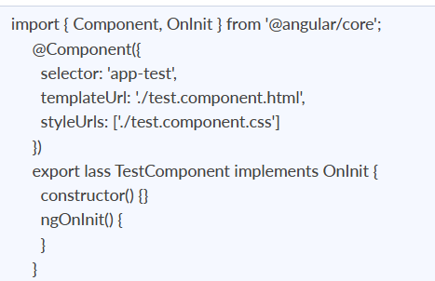
As we can see in the above image, our component is defined with @Component decorator.
- Modules
A module is a place where we can group components, directives, services, and pipes. Module decides whether the components, directives, etc can be used by other modules, by exporting or hiding these elements. Every module is defined with a @NgModule decorator.
By default, modules are of two types:
- Root Module
- Feature Module
Every application can have only one root module whereas, it can have one or more feature modules.
A root module imports BrowserModule, whereas a feature module imports CommonModule.
In the application that we created before, one can see that the root module is defined inside app.module.ts and this is how it looks:
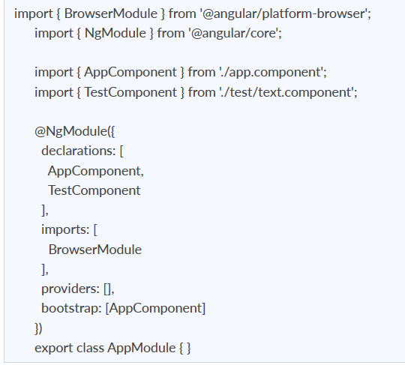
We can see in the above image that the component we created earlier is already imported in the declarations array.
To create a feature module, run the following command: ng g m test-module
The module is created inside the src/app/test-module/test-module.module.ts file:
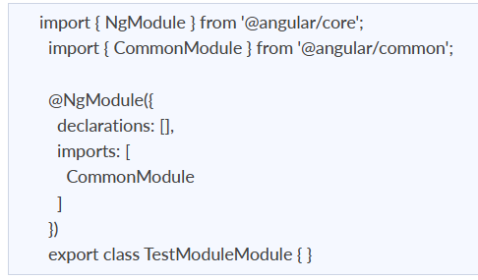
As one can see, CommonModule is imported since this is a feature module.
- Services
Services are objects which get instantiated only once during the lifetime of an application. The main objective of a service is to share data, functions with different components of an Angular application.
A service is defined using a @Injectable decorator. A function defined inside a service can be invoked from any component or directive.
To create a service, run the following command: ng g s test-service
The service will be created inside src/app/test-service.service.ts:
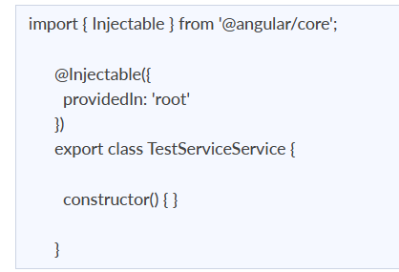
Any method/function defined inside the TestServiceService class can be directly used inside any component by just importing the service.

12. What is the scope?
In Angular, a scope is an object that refers to the application model. It is a context in which expressions can be executed. These scopes are grouped hierarchically, comparable to the DOM structure of the application. A scope aids in the propagation of various events and the monitoring of expressions.

13. What is data binding in Angular?
Data binding is one of the most significant and effective elements for creating communication between the DOM and the component. It makes designing interactive apps easier by reducing the need to worry about data pushing and pulling between the component and the template.
There are Four types of Data binding in Angular:
- Property Binding
- Event Binding
- String Interpolation
- Two way data binding
Property Binding: One method of data binding is called property binding. In property binding, we connect a DOM element's property to a field that is a declared property in our TypeScript component code. In reality, Angular transforms string interpolation into property binding internally.
Event Binding: Using event binding, you may respond to DOM events like button clicks and mouse movements. When a DOM event (such as a click, change, or keyup) occurs, the component's designated method is called.
String Interpolation: In order to export data from TypeScript code to an HTML template( view ), String Interpolation is a one way data binding approach. The data from the component is shown to the view using the template expression enclosed in double curly braces. The value of a component property is added by using string interpolation.

14. What is two way data binding in Angular?
Data sharing between a component class and its template is referred to as two-way data binding. If you alter data in one area, it will immediately reflate at the other end. This happens instantly and automatically, ensuring that the HTML template and TypeScript code are always up to date. Property binding and event binding are coupled in two-way data binding.

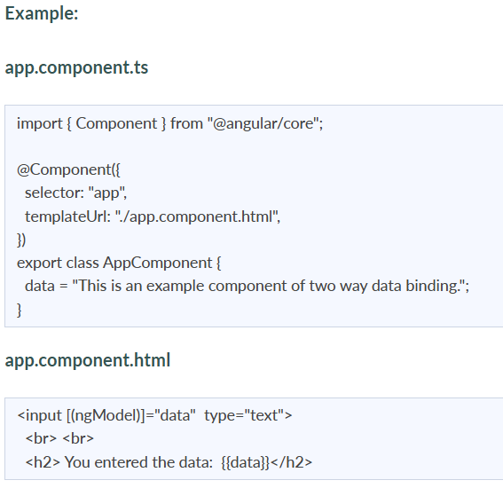
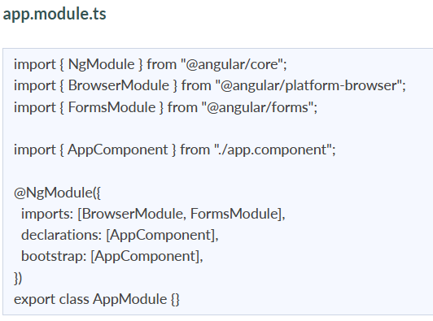

15. What are Decorators and their types in Angular?
Decorators are a fundamental concept in TypeScript, and because Angular heavily relies on TypeScript, decorators have become an important element of Angular as well.
Decorators are methods or design patterns that are labeled with a prefixed @ symbol and preceded by a class, method, or property. They enable the modification of a service, directive, or filter before it is utilized. A decorator, in essence, provides configuration metadata that specifies how a component, class, or method should be processed, constructed, and used at runtime. Angular includes a number of decorators which attach various types of metadata to classes, allowing the system to understand what all these classes signify and how they should function.
Types of decorators:
- Method Decorator: Method decorators, as the name implies, are used to add functionality to the methods defined within our class.
- Class Decorator: Class Decorators are the highest-level decorators that determine the purpose of the classes. They indicate to Angular that a specific class is a component or module. And the decorator enables us to declare this effect without having to write any code within the class.
- Parameter Decorator: The arguments of your class constructors are decorated using parameter decorators.
- Property Decorator: These are the second most popular types of decorators. They enable us to enhance some of the properties in our classes.

16. What are annotations in Angular ?
These are language features that are hard-coded. Annotations are merely metadata that is set on a class to reflect the metadata library. When a user annotates a class, the compiler adds an annotations property to the class, saves an annotation array in it, and then attempts to instantiate an object with the same name as the annotation, providing the metadata into the constructor. Annotations in AngularJs are not predefined, therefore we can name them ourselves.

17. What are pure Pipes?
These are pipelines that only employ pure functions. As a result, a pure pipe does not employ any internal state, and the output remains constant as long as the parameters provided remain constant. Angular calls the pipe only when the parameters being provided change. A single instance of the pure pipe is utilized in all components.

18. What are impure pipes?
Angular calls an impure pipe for each change detection cycle, independent of the change in the input fields. For each of these pipes, several pipe instances are produced. These pipes' inputs can be altered.
By default, all pipelines are pure. However, as demonstrated below, you can specify impure pipes using the pure property.
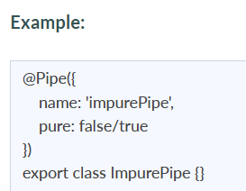

19. What is Pipe transform Interface in Angular?
An interface used by pipes to accomplish a transformation. Angular calls the transform function with the value of a binding as the first argument and any arguments as the second parameter in list form. This interface is used to implement custom pipes.
Example:
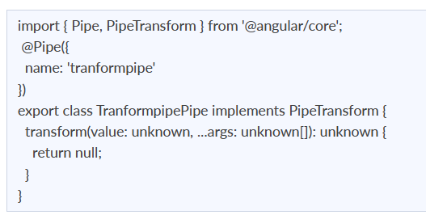

20. Write a code where you have to share data from the Parent to Child Component?
You have to share the data amongst the components in numerous situations. It may consist of unrelated, parent-child, or child-parent components.
The @Input decorator allows any data to be sent from parent to child.
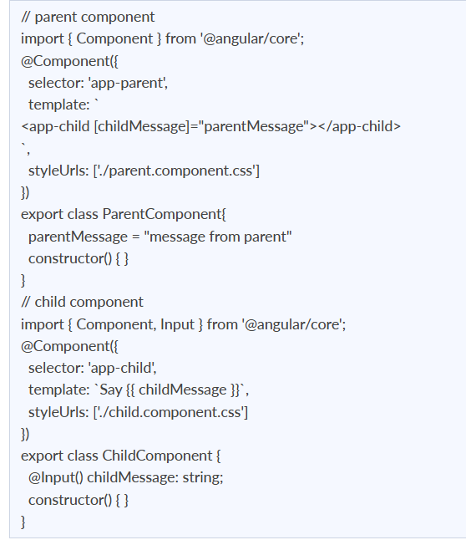

21. Create a TypeScript class with a constructor and a function.
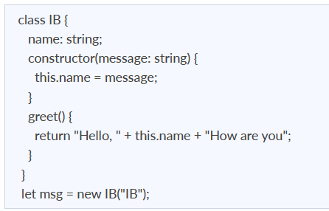

22. What are property decorators?
These are the second most popular types of decorators. They enable us to enhance some of the properties in our classes. We can certainly understand why we utilize any certain class property by using a property decorator.
There are many property decorators available for example @Input(), @Output, @ReadOnly(), @Override()
Example:
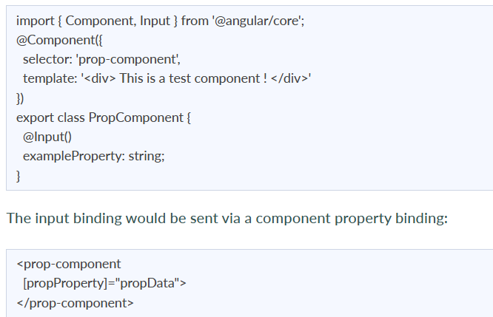

23. Angular by default, uses client-side rendering for its applications.
Can one make an angular application to render on the server-side?
Yes, angular provides a technology called Angular Universal, which can be used to render applications on the server-side.
The advantages of using Angular Universal are:
- First time users can instantly see a view of the application. This benefits in providing better user experience.
- Many search engines expect pages in plain HTML, thus, Universal can make sure that your content is available on every search engine, which leads to better SEO.
- Any server-side rendered application loads faster since rendered pages are available to the browser sooner.

24. What is Eager and Lazy loading?
- Loading: The eager loading technique is the default module-loading strategy. Eager loading feature modules are loaded before the program begins. This is primarily utilized for small-scale applications.
- Lazy Loading: Lazy loading loads the feature modules dynamically as needed. This speeds up the application. It is utilized for larger projects where all of the modules are not required at the start.

25. What is view encapsulation in Angular?
View encapsulation specifies if the component's template and styles can impact the entire program or vice versa.
Angular offers three encapsulation methods:
- Native: The component does not inherit styles from the main HTML. Styles defined in this component's @Component decorator are only applicable to this component.
- Emulated (Default): The component inherits styles from the main HTML. Styles set in the @Component decorator are only applicable to this component.
- None: The component's styles are propagated back to the main HTML and therefore accessible to all components on the page. Be wary of programs that have None and Native components. Styles will be repeated in all components with Native encapsulation if they have No encapsulation.
26. What are RxJs in Angular ?
RxJS is an acronym that stands for Reactive Extensions for JavaScript. It is used to enable the use of observables in our JavaScript project, allowing us to do reactive programming. RxJS is utilized in many popular frameworks, including Angular since it allows us to compose our asynchronous or callback-based code into a sequence of operations executed on a data stream that releases values from a publisher to a subscriber. Other programming languages, such as Java and Python, offer packages that allow them to develop reactive programs utilizing observables.
Most of the time, rxJs is used in HTTP calls with angular. Because http streams are asynchronous data, we can subscribe to them and apply filters to them.
Example: The following is a simple example of how RxJs can be utilized with HTTP calls.
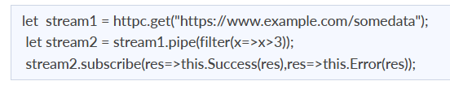
27. Explain string interpolation and property binding in Angular.
- String interpolation and property binding are parts of data-binding in Angular.
- Data-binding is a feature in angular, which provides a way to communicate between the component(Model) and its view(HTML template).
- Data-binding can be done in two ways, one-way binding and two-way binding.
- In Angular, data from the component can be inserted inside the HTML template. In one-way binding, any changes in the component will directly reflect inside the HTML template but, vice-versa is not possible. Whereas, it is possible in two-way binding.
- String interpolation and property binding allow only one-way data binding.
- String interpolation uses the double curly braces {{ }} to display data from the component. Angular automatically runs the expression written inside the curly braces, for example, {{ 2 + 2 }} will be evaluated by Angular and the output 4, will be displayed inside the HTML template. Using property binding, we can bind the DOM properties of an HTML element to a component's property. Property binding uses the square brackets [ ] syntax.

28. How are observables different from promises?
The first difference is that an Observable is lazy whereas a Promise is eager.
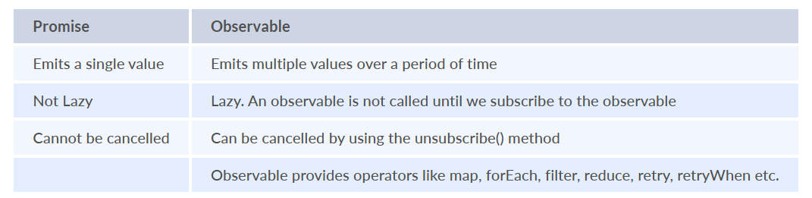
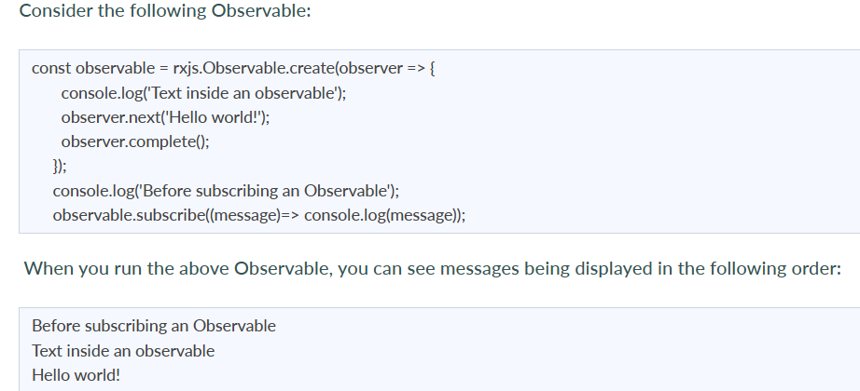
As you can see, observables are lazy. Observable runs only when someone subscribes to them hence, the message “Before subscribing…” is displayed ahead of the message inside the observable.
Now let’s consider a Promise:
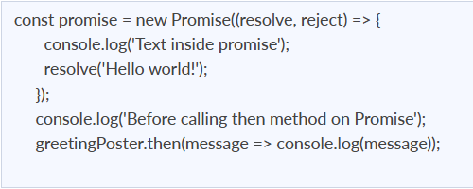
Running the above promise, the messages will be displayed in the following order:
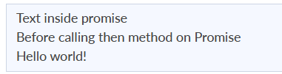
As you can see the message inside Promise is displayed first. This means that a promise runs before the then method is called. Therefore, promises are eager.
The next difference is that Promises are always asynchronous. Even when the promise is immediately resolved. Whereas an Observable, can be both synchronous and asynchronous.
The above example of an observable is the case to show that an observable is synchronous. Let’s see the case where an observable can be asynchronous:
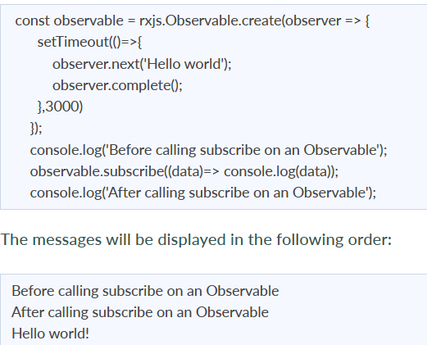
You can see in this case, observable runs asynchronously.
The next difference is that Observables can emit multiple values whereas Promises can emit only one value.
The biggest feature of using observables is the use of operators. We can use multiple operators on an observable whereas, there is no such feature in a promise.

29. Explain the concept of Dependency Injection?
Dependency injection is an application design pattern which is implemented by Angular.
It also forms one of the core concepts of Angular.
So what is dependency injection in simple terms?
Let’s break it down, dependencies in angular are nothing but services which have functionality. The functionality of a service, can be needed by various components and directives in an application. Angular provides a smooth mechanism by which we can inject these dependencies into our components and directives.
So basically, we are just making dependencies which are injectable across all components of an application.
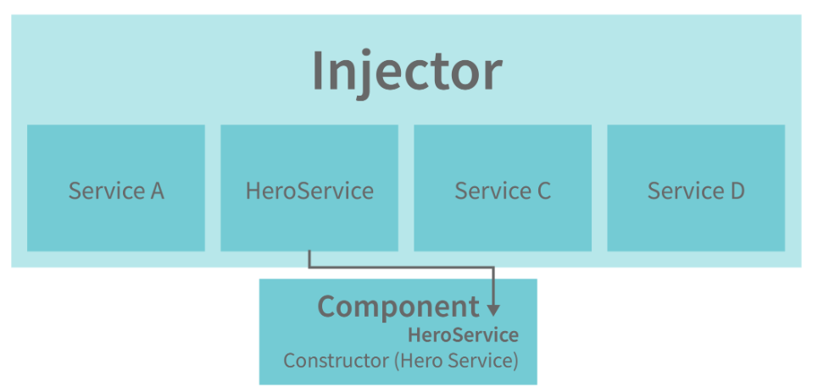
Let’s understand how DI (Dependency Injection) works:
Consider the following service, which can be generated using: ng g service test
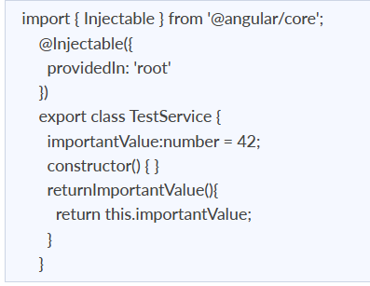
As one can notice, we can create injectable dependencies by adding the @Injectable decorator to a class.
We inject the above dependency inside the following component:
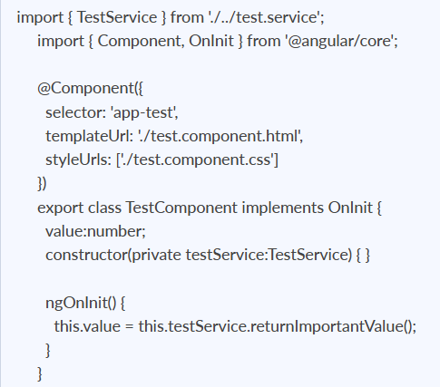
One can see we have imported our TestService at the top of the page. Then, we created an instance inside the constructor of the component and implemented the returnImportantValue function of the service.
From the above example, we can observe how angular provides a smooth way to inject dependencies in any component.

30. What are pipes in Angular explain with an example?
Pipes are functions that simplify the process of wiring up your JavaScript expressions and transforming them into their desired output. They can be compared to, say, string functions in other programming languages. Pipes also allow you to combine multiple expressions together, whether they're all values or some values and some declarations.
For example:
var css = myTheme.color | "red" ;
This line would assign a value to css , and it's equivalent to writing out the following code:
Pipes have several built-in functions that allow you to transform data, such as value and extract. We can also create our own custom pipes.
Pipes are data transformers that execute on an Angular Component's output. They take in data and return transformed data. For example, if you have an expression such as number | 1000, the number pipe will take data from the output and transform it into 1000. In Angular, there are many built-in pipes that you can use. You can also create your own custom pipes by implementing the PipeTransform interface in a class.
Pipes receive an input which can be a value expression, a function returning an expression, or even a component property., that outputs a number with a value of 1,000. With a pipe, you can transform this output into a formatted string of "1,000" or "1.000".
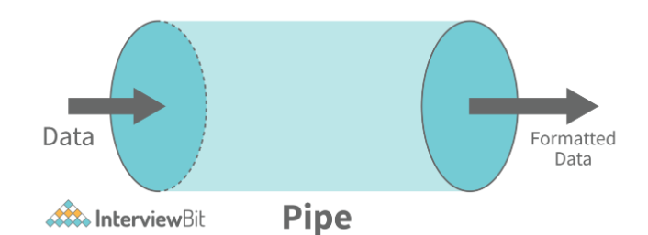
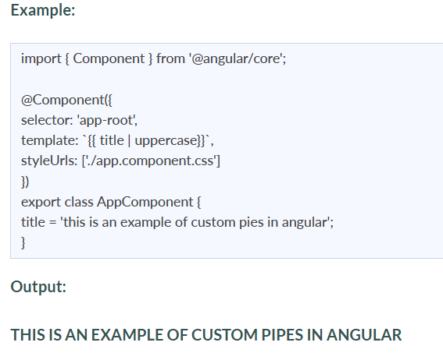

31. What exactly is a parameterized pipe?
To fine-tune its output, a pipe can receive any number of optional parameters. The parameterized pipe is constructed by first stating the pipe name followed by a colon (:) and then the parameter value. If the pipe supports several arguments, use colons to separate the values.
Example: Let's look at a birthday with a certain format (dd/MM/yyyy):
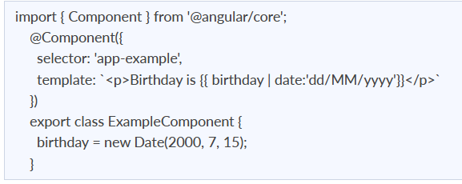

32. What are class decorators?
Class Decorators are the highest-level decorators that determine the purpose of the classes. They indicate to Angular that a specific class is a component or module. And the decorator enables us to declare this effect without having to write any code within the class.
Example:
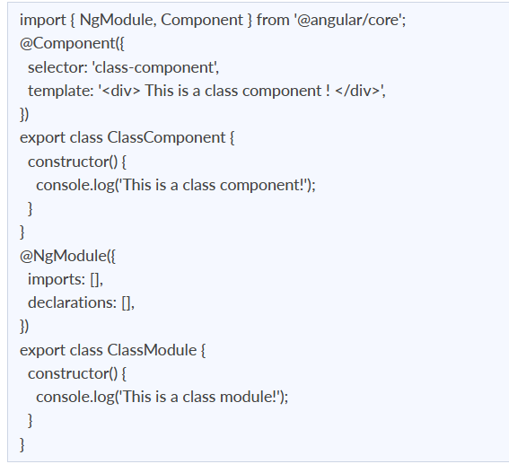
It is a component or module in which no code in the class is required to tell Angular. We only need to design it, and Angular will take care of the rest.

33. What are Method decorators?
Method decorators, as the name implies, are used to add functionality to the methods defined within our class.
Example: @HostListener, is a good example of method decorators.
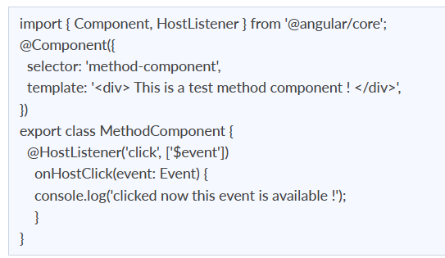
The @HostListener decorator is used before the onHostClick () method in the above example code.

34. Explain MVVM architecture
MVVM architecture consists of three parts:
- Model
- View
- ViewModel
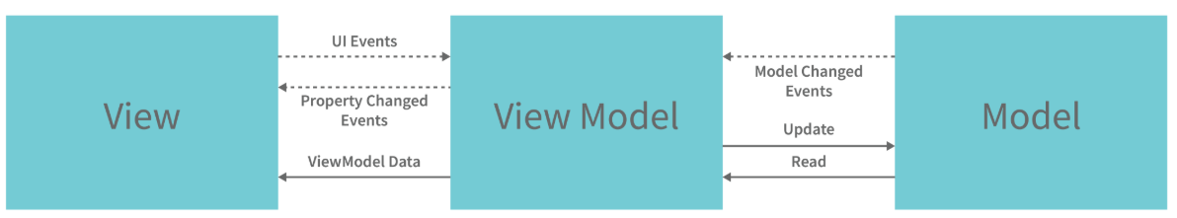
- Model contains the structure of an entity. In simple terms it contains data of an object.
- View is the visual layer of the application. It displays the data contained inside the Model. In angular terms, this will be the HTML template of a component.
- ViewModel is an abstract layer of the application. A viewmodel handles the logic of the application. It manages the data of a model and displays it in the view.
View and ViewModel are connected with data-binding (two-way data-binding in this case). Any change in the view, the viewmodel takes a note and changes the appropriate data inside the model.

35. What is the Component Decorator in Angular?
TypeScript classes are used to create components. This class genre is then decorated with the "@Component" decorator. The decorator's function is to take a metadata object holding component information and decorate it.
A Decorator is always preceded by @. The Decorator must come before the class definition. We can also make our own decorators.
Example: The example below shows us a Class decorated with the @Component decorator.
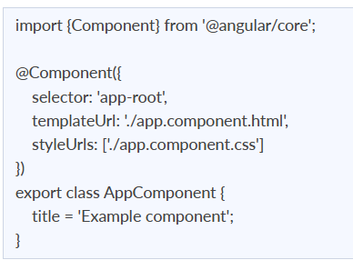
The metadata object received by the decorator has values such as templateUrl, selector, and others, with the templateUrL property pointing to an HTML file that defines what you see on the application.

36. What are lifecycle hooks in Angular? Explain a few lifecycle hooks.
Every component in Angular has a lifecycle, and different phases it goes through from the time of creation to the time it's destroyed. Angular provides hooks to tap into these phases and trigger changes at specific phases in a lifecycle.
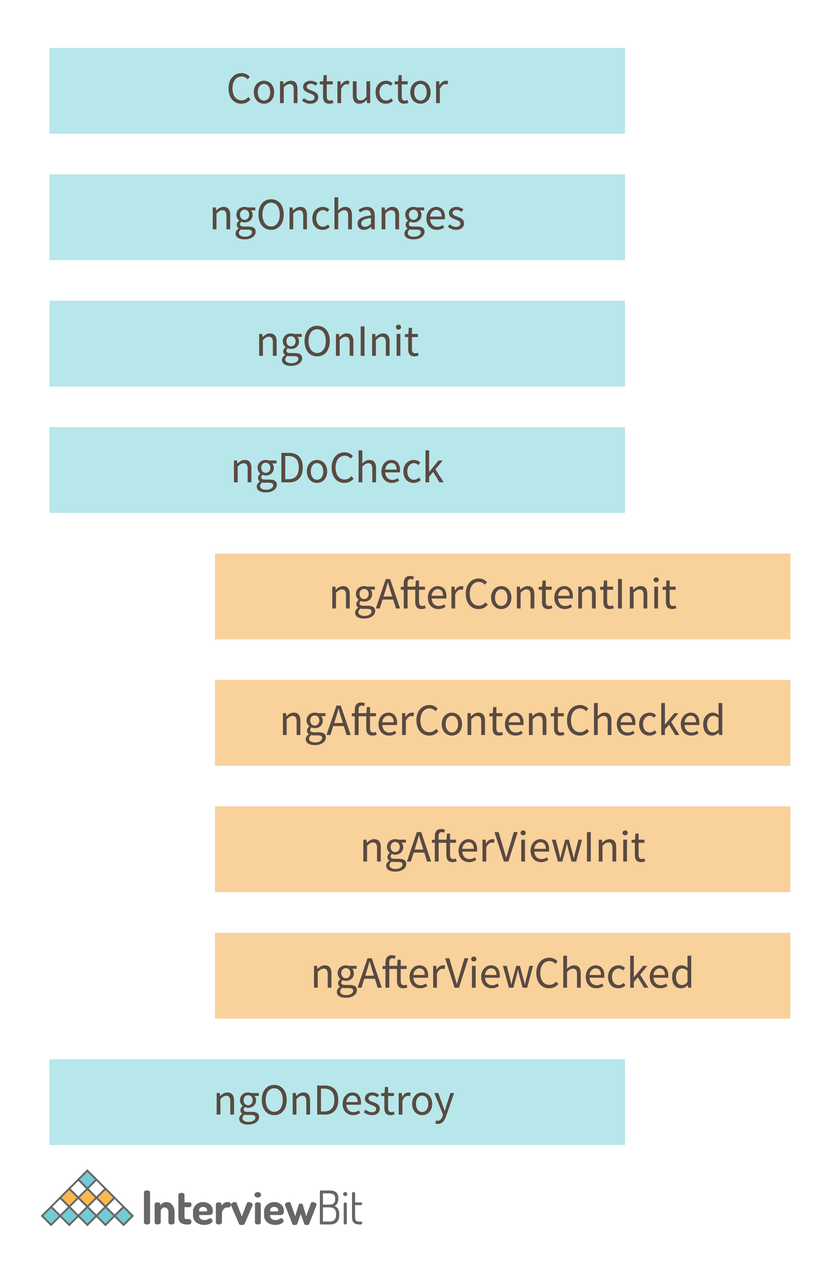
- ngOnChanges( ) This hook/method is called before ngOnInit and whenever one or more input properties of the component change.
This method/hook receives a SimpleChanges object which contains the previous and current values of the property.
- ngOnInit( ) This hook gets called once, after the ngOnChanges hook.
It initializes the component and sets the input properties of the component.
- ngDoCheck( ) It gets called after ngOnChanges and ngOnInit and is used to detect and act on changes that cannot be detected by Angular.
We can implement our change detection algorithm in this hook. ngAfterContentInit( ) It gets called after the first ngDoCheck hook. This hook responds after the content gets projected inside the component.
- ngAfterContentChecked( ) It gets called after ngAfterContentInit and every subsequent ngDoCheck. It responds after the projected content is checked.
- ngAfterViewInit( ) It responds after a component's view, or a child component's view is initialized.
- ngAfterViewChecked( ) It gets called after ngAfterViewInit, and it responds after the component's view, or the child component's view is checked.
- ngOnDestroy( ) It gets called just before Angular destroys the component. This hook can be used to clean up the code and detach event handlers.
Let’s understand how to use ngOnInit hook, since it’s the most often used hook. If one has to process a lot of data during component creation, it’s better to do it inside ngOnInit hook rather than the constructor:
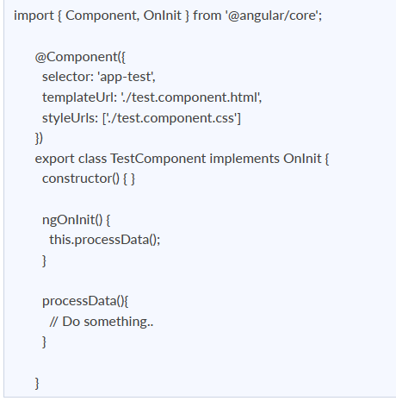
As you can see we have imported OnInit but we have used ngOnInit function. This principle should be used with the rest of the hooks as well.

37. What are router links?
RouterLink is an anchor tag directive that gives the router authority over those elements. Because the navigation routes are set.
Example: As seen below, you may pass string values to the router-link directive.
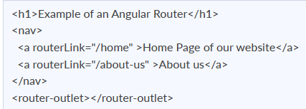

38. What exactly is the router state?
RouterState is a route tree. This tree's nodes are aware of the "consumed" URL segments, retrieved arguments, and processed data. You may use the Router service and the routerState property to get the current RouterState from anywhere in the application.
Example:
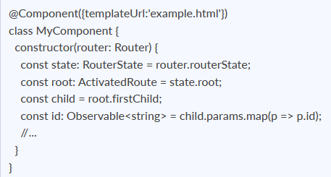

39. What does Angular Material means?
Angular Material is a user interface component package that enables professionals to create a uniform, appealing, and fully functioning websites, web pages, and web apps. It does this by adhering to contemporary web design concepts such as gentle degradation and browser probability.

40. What is ngOnInit?
ngOnInit is a lifecycle hook and callback function used by Angular to mark the creation of a component. It accepts no arguments and returns a void type.
Example:
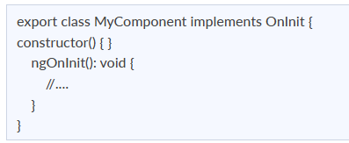

41. What is transpiling in Angular ?
Transpiling is the process of transforming the source code of one programming language into the source code of another. Typically, in Angular, this implies translating TypeScript to JavaScript. TypeScript (or another language like as Dart) can be used to develop code for your Angular application, which is subsequently transpiled to JavaScript. This occurs naturally and internally.

42. What are HTTP interceptors ?
Using the HttpClient, interceptors allow us to intercept incoming and outgoing HTTP requests. They are capable of handling both HttpRequest and HttpResponse. We can edit or update the value of the request by intercepting the HTTP request, and we can perform some specified actions on a specific status code or message by intercepting the answer.
Example: In the following example we will set the Authorization header Bearer for all the requests:
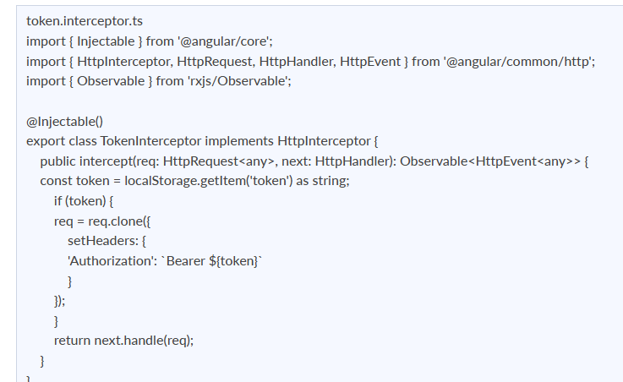
We have to register the interceptor as singleton in the module providers
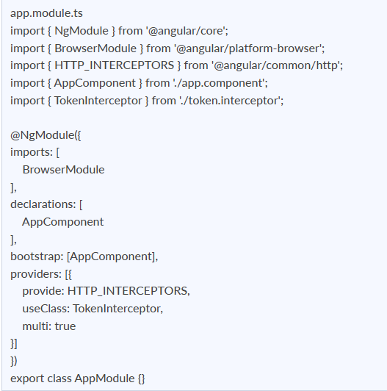

43. What is AOT compilation? What are the advantages of AOT?
Every Angular application consists of components and templates that the browser cannot understand. Therefore, all the Angular applications need to be compiled first before running inside the browser.
Angular provides two types of compilation:
- JIT(Just-in-Time) compilation
- AOT(Ahead-of-Time) compilation
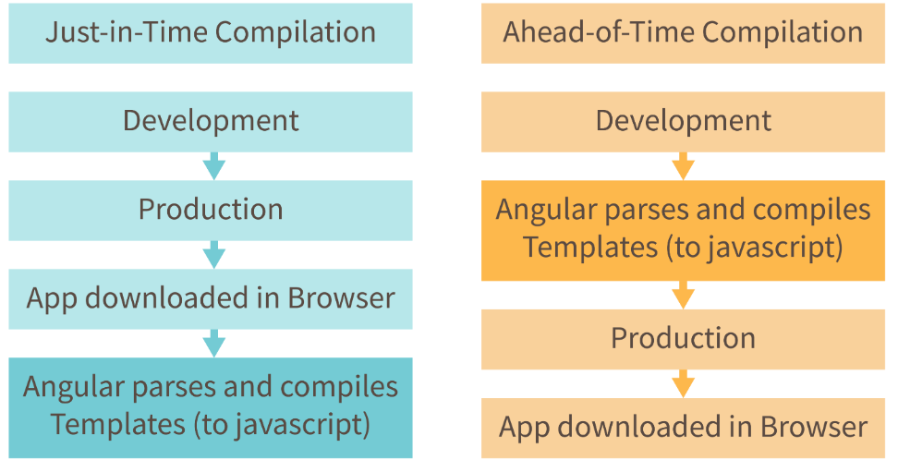
In JIT compilation, the application compiles inside the browser during runtime. Whereas in the AOT compilation, the application compiles during the build time.
The advantages of using AOT compilation are:
- Since the application compiles before running inside the browser, the browser loads the executable code and renders the application immediately, which leads to faster rendering.
- In AOT compilation, the compiler sends the external HTML and CSS files along with the application, eliminating separate AJAX requests for those source files, which leads to fewer ajax requests.
- Developers can detect and handle errors during the building phase, which helps in minimizing errors.
- The AOT compiler adds HTML and templates into the JS files before they run inside the browser. Due to this, there are no extra HTML files to be read, which provide better security to the application.
By default, angular builds and serves the application using JIT compiler:
ng build
ng serve
For using AOT compiler following changes should be made:
ng build --aot
ng serve --aot

44. What is Change Detection, and how does the Change Detection Mechanism work?
The process of synchronizing a model with a view is known as Change Detection. Even when utilizing the ng Model to implement two-way binding, which is syntactic sugar on top of a unidirectional flow. Change detection is incredibly fast, but as an app's complexity and the number of components increase, change detection will have to do more and more work.
Change Detection Mechanism-moves only ahead and never backward, beginning with the root component and ending with the last component. This is what one-way data flow entails. The tree of components is the architecture of an Angular application. Each component is a child, but the child is not a parent. A $digest loop is no longer required with the one-way flow.

45. What is a bootstrapping module?
Every application contains at least one Angular module, which is referred to as the bootstrapping module. AppModule is the most popular name for it.
Example: The following is the default structure of an AngularCLI-generated AppModule:
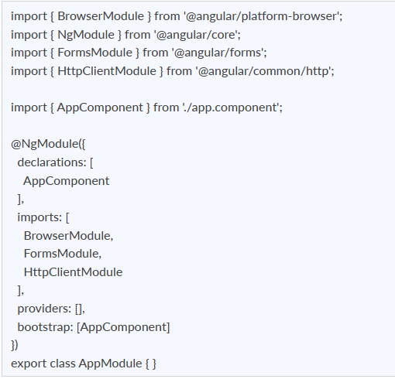

46. How do you choose an element from a component template?
To directly access items in the view, use the @ViewChild directive. Consider an input item with a reference.
<input #example>
and construct a view child directive that is accessed in the ngAfterViewInit lifecycle hook
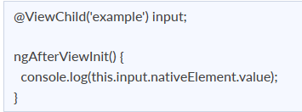

47. How does one share data between components in Angular?
Following are the commonly used methods by which one can pass data between components in angular:
- Parent to child using @Input decorator
Consider the following parent component:
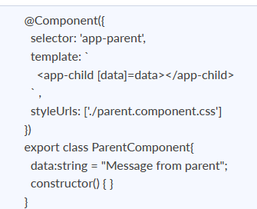
In the above parent component, we are passing “data” property to the following child component:
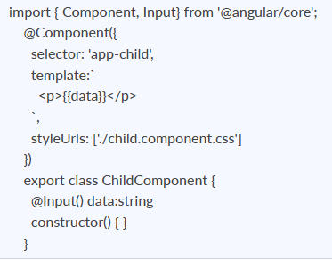
In the child component, we are using @Input decorator to capture data coming from a parent component and using it inside the child component’s template.
- Child to parent using @ViewChild decorator
Child component:
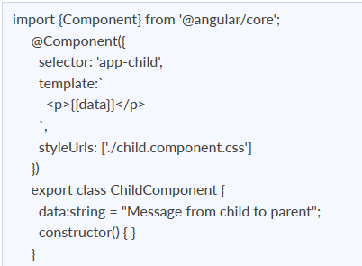
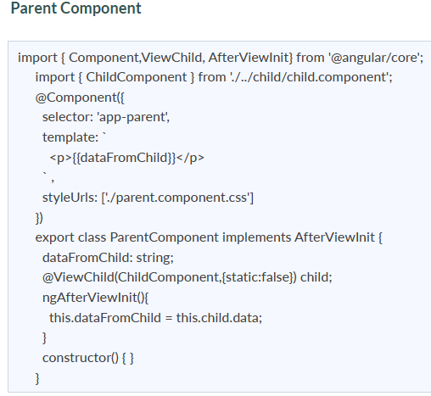
In the above example, a property named “data” is passed from the child component to the parent component.
@ViewChild decorator is used to reference the child component as “child” property.
Using the ngAfterViewInit hook, we assign the child’s data property to the messageFromChild property and use it in the parent component’s template.
- Child to parent using @Output and EventEmitter
In this method, we bind a DOM element inside the child component, to an event ( click event for example ) and using this event we emit data that will captured by the parent component:
Child Component:
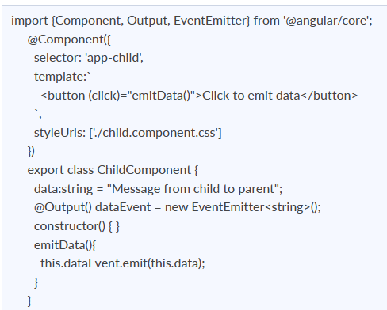
As you can see in the child component, we have used @Output property to bind an EventEmitter. This event emitter emits data when the button in the template is clicked.
In the parent component’s template we can capture the emitted data like this:
<app-child (dataEvent)="receiveData($event)"></app-child>
Then inside the receiveData function we can handle the emitted data:
receiveData($event){
this.dataFromChild = $event;
}
48. How do you deal with errors in observables?
Instead of depending on try/catch, which is useless in an asynchronous context, you may manage problems by setting an error callback on the observer.
Example: You may create an error callback as shown below.
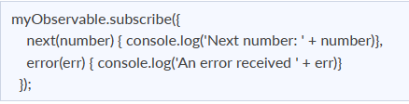

49. How can I include SASS into an Angular project?
You may use the ng new command while building your project using angular CLI. All of your components are generated using preset sass files.
ng new <Your_Project_Name> --style = sass
If you want to change the style of your project, use the ng set command.
ng set defaults.styleExt scss

50. What happens when you use the script tag within a template?
Angular detects the value as unsafe and sanitizes it automatically, removing the script tag but retaining safe material such as the script tag's text content. This reduces the potential of script injection attacks. If you continue to use it, it will be disregarded, and a warning will display in the browser console.
Example: Consider the case of innerHtml property binding, which results in an XSS vulnerability.
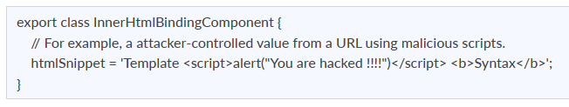

51. How do you handle 404 and unauthorized routes?
- Use a wildcard route for 404 pages
- Use route guards to restrict access
- Redirect unauthorized users to a dedicated unauthorized route
52. How do you configure routes in Angular using RouterModule.forRoot() vs forChild()?
Angular provides two methods to register routes.
- RouterModule.forRoot() is used in the root module (AppModule). It initializes the router service and should be called only once in the application.
- RouterModule.forChild() is used in feature modules, especially lazy loaded modules. It registers additional routes without creating a new router instance.
Using forRoot() in multiple modules can lead to unexpected routing behavior and should be avoided.

53. What is the difference between path parameters and query parameters, and how do you read each?
Path parameters are mandatory values embedded in the URL path.
Example URL:
/users/10
Access using:
- ActivatedRoute.paramMap
Query parameters are optional and appear after ?.
Example URL:
/users?id=10&role=admin
Access using:
- ActivatedRoute.queryParamMap
Path parameters are used for resource identification, while query parameters are commonly used for filters, sorting, and pagination.

54. What is the difference between ActivatedRoute.snapshot and ActivatedRoute observables?
- ActivatedRoute.snapshot provides a static value when the component is initialized.
- ActivatedRoute observables (paramMap, queryParamMap) emit new values when route parameters change.
Snapshot is suitable for routes that do not change during the component lifecycle. Observables should be used when the same component instance handles multiple route changes.

55. What is pathMatch: 'full' and why is it important?
pathMatch defines how Angular matches a URL segment.
- 'prefix' matches partial URLs and is the default.
- 'full' matches the complete URL.
pathMatch: 'full' is required for redirect routes, especially for empty paths, to prevent incorrect or infinite redirections.

56. How do redirectTo routes work and what are common pitfalls?
The redirectTo property redirects one route to another.
Common issues include:
- Missing pathMatch: 'full
- Incorrect ordering of redirect routes
- Redirect loops
- Placing redirect routes after wildcard routes
Redirect routes should always be defined before the wildcard route.

57. What is a wildcard route (**) and where should it be placed?
A wildcard route matches any URL that does not match earlier route definitions.
Example:
{ path: '**', component: PageNotFoundComponent }
It must be placed at the end of the route configuration to avoid overriding valid routes.

58. What are route guards and their differences?
Route guards control navigation access.
- CanActivate checks access to a route
- CanActivateChild checks access to child route
- CanDeactivate prevents leaving a route
- CanLoad prevents loading lazy modules
- CanMatch determines whether a route should be matched
CanMatch is preferred over CanLoad in newer Angular versions.

59. What is a Resolver in Angular routing and when should it be used?
A Resolver fetches data before route activation.
It is useful when:
- The component requires data before rendering
- You want to avoid loading states inside components
- SEO or initial page load experience matters
Resolved data is accessed using ActivatedRoute.data.
60. How do you implement lazy-loaded routes using loadChildren?
Lazy loading loads feature modules only when the route is accessed.
Example:
{
path: 'admin',
loadChildren: () =>
import('./admin/admin.module').then(m => m.AdminModule)
}
Lazy loading improves application performance and reduces initial bundle size.

61. What are child routes and how does nested router-outlet work?
Child routes allow nested routing under a parent route.
The parent component template must contain <router-outlet> for rendering child components.
This approach is commonly used for dashboards and layout based navigation.

62. What are auxiliary routes or named outlets?
Auxiliary routes allow multiple routes to be active simultaneously.
They are implemented using named outlets and are useful for side panels, modals, or secondary views.

63. What is the difference between router.navigate() and navigateByUrl()?
- navigate() accepts route segments and supports relative navigation.
- navigateByUrl() accepts a full URL string.
navigate() is preferred for dynamic routes and parameters.

64. What are NavigationExtras and their use cases?
NavigationExtras provide additional routing options.
Common properties:
- state for passing non-URL data
- queryParamsHandling for merging or preserving query params
- replaceUrl to avoid adding history entries
- skipLocationChange to navigate without URL change
65. What is routerLinkActive and how is active state handled?
routerLinkActive applies a CSS class when the linked route is active.
For nested routes, routerLinkActiveOptions with exact: true helps avoid incorrect active states.

66. How do you subscribe to Router events and why is it useful?
Angular Router emits events such as NavigationStart and NavigationEnd.
Subscribing to these events is useful for:
- Showing global loaders
- Logging navigation
Tracking analytics
67. What is RouteReuseStrategy and when is it useful?
RouteReuseStrategy allows reuse of route components instead of destroying them.
It is commonly used in tab based interfaces to preserve component state and improve performance.

68. How do you implement scroll position restoration and anchor scrolling?
Scroll restoration and anchor scrolling are enabled in router configuration using router options.
This improves user experience when navigating between long pages.

69. How do you pass static data using route data?
Static data can be passed using the data property in route configuration.
It is accessed in components using ActivatedRoute.data and is useful for metadata such as titles and permissions.

70.What is a standalone component, and why did Angular move away from NgModules as the default?
Standalone components (default since Angular 17) declare their own dependencies directly via the imports array, instead of being registered in an NgModule. This removes a layer of indirection for simpler apps and lets you bootstrap an app with bootstrapApplication() instead of a root module. NgModules still work and are common in larger, older codebases, but new Angular code defaults to standalone.

71.What is dependency injection in Angular, and how does the inject() function differ from constructor injection?
Dependency injection lets Angular provide a class with the services it needs rather than the class creating them itself. Constructor injection (constructor(private http: HttpClient)) is the traditional pattern.
The inject() function does the same thing but can be called outside a constructor — inside a field initializer, a factory function, or a functional guard/interceptor, which is why inject() has become the default in modern Angular code, especially with standalone APIs.

72.Name Angular’s component lifecycle hooks and what each is for
ngOnChanges (input changes), ngOnInit (after first input binding), ngDoCheck (custom change detection), ngAfterContentInit/ngAfterContentChecked (projected content), ngAfterViewInit/ngAfterViewChecked (view and child views), and ngOnDestroy (cleanup).
In Signals-based components, several of these are increasingly replaced by afterRenderEffect() or simply reacting to signal changes directly — worth asking a candidate if they know this shift is happening.

73.What’s the difference between a template-driven form and a reactive form?
Template-driven forms build the form structure in the template using directives like ngModel, with Angular inferring the model. Reactive forms build the form structure explicitly in the component using FormGroup and FormControl, giving more control and easier unit testing.
In recent Angular versions, there’s now a third option, Signal Forms, where the form’s state is a writable signal, and the form is a structured interface over it. It’s worth asking a candidate if they’ve used this yet, since adoption is still early.

74.What is a pipe, and what’s the difference between a pure and impure pipe?
A pipe transforms a value for display ({{ value | currency }}). A pure pipe (the default) only re-runs when its input reference changes; an impure pipe re-runs on every change-detection cycle regardless, which is expensive and almost always avoidable with a pure pipe or a computed signal instead.

75.What’s the difference between @Input()/@Output() and the newer signal-based input()/output() functions?
The decorator-based @Input()/@Output() pattern is the long-standing way to pass data into and out of a component. The function-based input() and output() (stable since Angular 17) integrate directly with signals — an input() is itself a signal you can read reactively and compose with computed(), without a separate property and change-detection cycle to think about.

76.What’s the difference between a route guard and a resolver, and how has this changed in recent Angular versions?
A guard (canActivate, canDeactivate) decides whether navigation is allowed to proceed. A resolver pre-fetches data before the route activates, so the component loads with data already available instead of showing a loading state. Both used to be class-based; modern Angular favors functional guards and resolvers (plain functions using inject()) over the older class-based interface pattern.

77.How do you unit test a component that depends on signals?
TestBed still configures the testing module, but reading signal values in a test is as simple as calling the signal like a function (component.count()) rather than subscribing or using fixture.detectChanges() to force a check. If the component is zoneless-compatible, TestBed runs zoneless by default when Zone.js isn’t loaded, so tests increasingly rely on fixture.whenStable() rather than manually forcing change detection.

78.What’s a common XSS risk in Angular, and how does Angular protect against it by default?
Angular sanitizes values bound through interpolation and most property bindings by default, stripping unsafe HTML/JS before rendering. The risk reappears when a developer deliberately bypasses this, most often via [innerHTML] with unsanitized user content, or by using bypassSecurityTrustHtml without verifying that the source is safe. A candidate who’s thought about this will mention that sanitization isn’t a substitute for validating and escaping data server-side, too.

79.What does @defer do, and how is it different from route-level lazy loading?
@defer splits a piece of template (not a whole route) into its own JavaScript chunk, loaded only when a trigger fires: on viewport, on interaction, on idle, or a custom condition. Route-level lazy loading defers an entire page; @defer lets you defer a single heavy component within a page that loads immediately otherwise (a chart, a comment section, anything below the fold).
Combined with SSR, @defer also powers incremental hydration: the server can render a deferred block’s HTML up front for fast paint, while the client delays running its JavaScript until a hydrate on trigger fires, so a page can look complete immediately without paying the full interactivity cost up front.

80. “You need to track a filter value that updates a list as the user types. Would you model that as a signal or an Observable, and why?”
A strong candidate recognizes this as synchronous, locally-owned UI state: exactly what signal() and computed() were built for. They’d reach for a plain signal for the filter text and a computed() for the filtered list, and explain that this avoids subscription management entirely: no takeUntil, no async pipe, no manual cleanup.
They’d reserve RxJS for genuinely asynchronous, event-stream-shaped problems, debounced search-as-you-type hitting a real API, WebSocket messages, or anything that needs switchMap/debounceTime-style operators.
The weak answer defaults to RxJS out of habit, because that’s what they’ve always used for “reactive” state, without considering that the actual problem is synchronous.
What a strong answer covers:
Signal + computed() for synchronous, locally-owned state (no subscriptions, no cleanup)
RxJS reserved for genuinely asynchronous, event-stream problems — debounced search hitting an API, WebSocket messages, multi-step operator chains

81. “A user selects an item from a dropdown, and a detail panel shows that item’s data, but the user can also locally edit the detail panel before saving. How would you model that?”
This is the textbook case for linkedSignal(): a value that’s initialized from a source signal (the selection) but needs to stay independently writable afterward (the local edit). A candidate who knows linkedSignal() will name it directly and explain why a plain computed() doesn’t work here — computed signals are read-only, and this scenario needs both reactivity and the ability to override the derived value locally.
For data fetching, ask how they’d load that item’s full detail from an API. A candidate current on Angular 19+ will mention the resource() API (or httpResource()), which lets you treat async data as a signal-like value, with built-in loading and error state, instead of manually wiring an Observable through async pipe or a manual subscription.
What a strong answer covers:
Naming linkedSignal() directly, and explaining why computed() doesn’t work here; computed signals are read-only, and this scenario needs a value that’s both derived and independently writable
Naming resource() or httpResource() for the data-fetching half, with built-in loading and error state, instead of manually wiring an Observable through async pipe

82. “At what point does ‘just use a signal in a service’ stop being good enough?”
A senior developer ties this to scope and complexity, not personal preference: a signal in an injectable service is fine for state shared by a handful of components with simple update logic.
Once you need structured derived state, encapsulation (private state that can’t be mutated from outside), or coordinated async operations across multiple consumers, NgRx’s signalStore() (with withState, withComputed, withMethods) gives you that structure without bringing back the action/reducer/effect boilerplate of classic NgRx.
Watch for a candidate who reaches for full NgRx (the original, non-signal version) out of habit on a project that doesn’t need it — that’s the same “default to the familiar tool” problem the article already calls out with RxJS overuse, just one layer up.
What a strong answer covers:
Tying the decision to scope, not preference: a signal in a service is enough for simple, narrowly shared state
Naming the actual triggers for signalStore(): structured derived state, real encapsulation (private state that can’t be mutated externally), or coordinating async operations across multiple consumers
Flagging reflexive use of classic NgRx (actions/reducers/effects) on a project that doesn’t need that much structure, as the same red flag as defaulting to RxJS out of habit

83. “Your app has a dashboard component that stays mounted for the entire user session. It subscribes to three WebSocket streams and two polling intervals. How do you make sure nothing leaks when the user logs out?”
A senior developer jumps to cleanup strategy immediately. They’ll mention a destroy subject with takeUntil, or say they’d use the async pipe wherever possible so Angular handles unsubscription without manual intervention.
Then they go further: manual .subscribe() calls without cleanup are the most common source of leaks in long-lived components, and the ones created inside setTimeout or event listeners are the easiest to miss because they’re not obviously tied to the component lifecycle.
Watch out for the candidate who says “I unsubscribe in ngOnDestroy” and nothing else. That answer may sound right, but it skips the hard part: tracking which subscriptions actually need cleanup, especially in components that dynamically create them. This is a gap that shows up after a user has had a session open for 20 minutes, and the browser tab starts consuming memory that it never releases.
What a strong answer covers:
- Cleanup via a destroy$ Subject + takeUntil, or preferring the async pipe so Angular handles unsubscription automatically
- Naming the riskiest leak sources specifically: manual .subscribe() calls with no teardown, and subscriptions created inside setTimeout or event listeners
- Recognizing that dynamically created subscriptions (not declared once in ngOnInit) need their own tracking, since a single destroy$ pattern can miss them

84. “You’re building an autocomplete search and a form save button. Which flattening operator do you use for each, and why?”
The right answer addresses what breaks if you pick the wrong one. A strong candidate says to use switchMap for the search without hesitation, because you only care about the latest keystroke’s result, and canceling stale requests is the correct behavior.
For the save, they slow down: concatMap if order matters, exhaustMap if you want to ignore duplicate clicks while a save is in flight. Either is defensible, but what matters is that they recognize these are different problems.
Get this wrong and a user’s form submission disappears on a double-click. The backend gets blamed first, but it’s always the frontend.
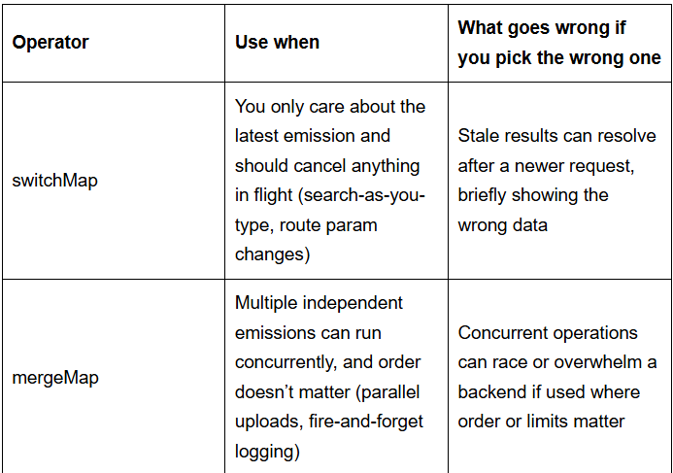
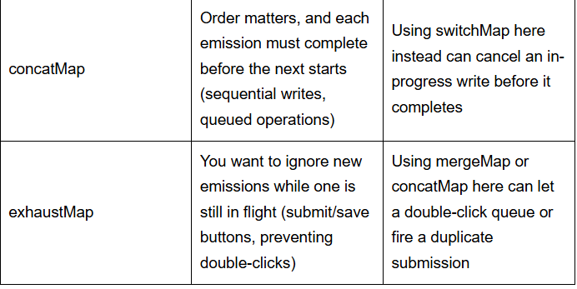
What a strong answer covers:
- switchMap for the search bar — cancels stale requests automatically
- concatMap or exhaustMap for the save button, depending on whether queuing or ignoring duplicates is the right behavior
- Naming a concrete failure mode for picking wrong (a vanished form submission, a race condition) rather than just naming the operator

85. “One of your three dashboard streams throws an error. How do you keep the other two running and show the user something useful?”
A senior developer starts with the part most candidates miss: an unhandled error doesn’t just break the failing stream; it also kills the entire observable chain. From there, they describe wrapping each stream individually with catchError, returning a fallback value or an empty observable so sibling streams stay alive. They think about the user experience too; a partial view with a clear error state for the broken section, not a blank page.
“I’d add a .catch somewhere” is the answer that should end the conversation. No specificity about where in the chain, no mention of what the user actually sees, and no awareness that the stream dies permanently without recovery. In a real app, that means one flaky API endpoint takes down the entire dashboard.
What a strong answer covers:
Naming the actual failure mechanism first: an unhandled error doesn’t just kill the failing stream, it kills the whole observable chain it’s part of
Wrapping each stream individually with catchError, returning a fallback value or an empty observable, so sibling streams keep running
Addressing the user-facing side, not just the code: a partial view with a visible error state for the broken section, rather than a blank page or silent failure

86.“Your teammate wrote a 30-line RxJS chain to toggle a boolean flag based on a button click. What’s your reaction?”
This matters more now that AI tools are in the mix. Copilot and Cursor will generate a functioning RxJS chain without hesitation. That makes it easier than ever to arrive at an interview with complex-looking code you didn’t fully think through.
A senior developer’s first reaction isn’t to fix the chain, but to question why it exists. A simple property toggle or an Angular signal (16+) would be clearer for the team, easier to test, and easier for someone new to debug on a Friday afternoon.
A mid-level candidate tends to engage with the chain on its own terms. They’ll suggest breaking it into smaller operators or adding comments. They’re optimizing within the wrong approach instead of stepping back. That instinct to reach for RxJS by default and then defend it is worth probing. Ask them what it would cost a new hire to understand that code on day one.
What a strong answer covers:
Questioning why the RxJS chain exists at all, rather than jumping straight to fixing or simplifying it
Naming a simpler, more appropriate alternative for the actual problem — a plain property toggle, or a signal, for state that doesn’t need a stream
Framing the cost in terms of team maintainability, not just personal preference: what it takes for a new hire to debug that code on a Friday afternoon

87.“You switch a component to OnPush, and the view stops updating when data changes in a parent service. What happened, and how do you fix it without reverting to Default?”
A developer who’s used OnPush in production knows this scenario immediately. The component isn’t receiving a new object reference. OnPush only triggers re-render when @Input() references change, an event fires inside the component, or an observable piped through async emits. They’ll describe the fix without prompting: pass immutable data or convert the service to expose an observable that the component consumes via an async pipe.
The weak answer is “switch it back to Default.” That tells you exactly what happened on their last project; they hit this, couldn’t figure it out, and reverted. It’s a compounding pattern: Every time a performance problem surfaces, the path of least resistance is to opt out of the solution.
What a strong answer covers:
Identifying the actual cause immediately: OnPush only re-renders on a new @Input() reference, an internal event, or an observable emission through the async pipe — not on a mutated object
Naming a real fix rather than reverting: passing immutable data, or converting the service to expose an observable the component consumes via async pipe
Treating “switch it back to Default” as a red flag, not a valid answer — it signals they hit the problem before and gave up, rather than solving it

88.“Users report that a data table feels sluggish on a mid-range Android device. You profile it and see the component re-renders on every mouse move. What’s your diagnostic process?”
A strong candidate doesn’t guess. First, they open Angular DevTools’ profiler, check whether the component is within a Default change detection tree, then look for event listeners that trigger unnecessary cycles or expensive computations in the template.
If they’ve done this before, they mention logging in ngDoCheck to catch exactly when detection fires, or using ChangeDetectorRef to isolate which subtree is causing the thrash.
“I’d add OnPush” without profiling first is a guess. It might work, or it might mask the real problem while introducing stale-data bugs in another component. Profiling before changing anything isn’t a best practice at this level; it’s table stakes.
What a strong answer covers:
Starting with diagnosis, not a guess — opening Angular DevTools’ profiler before changing any code
Checking specific causes in order: whether the component sits in a Default change-detection tree, event listeners triggering unnecessary cycles, and expensive template computations
Mentioning at least one deeper diagnostic tool when relevant — logging in ngDoCheck, or using ChangeDetectorRef to isolate which subtree is thrashing
Treating “just add OnPush” without profiling first as a guess, not a fix — it can mask the real problem while introducing new stale-data bugs elsewhere

89. “When do you use the async pipe vs. manually subscribing and calling detectChanges()?”
A clear answer here: async pipe as the default, always. It handles subscription and unsubscription and automatically triggers change detection, as there’s no manual cleanup and no risk of forgetting to unsubscribe. Manual detectChanges() belongs in specific edge cases: updating a view inside runOutsideAngular, or responding to a third-party event that Angular’s zone doesn’t know about.
If a candidate reaches for detectChanges() regularly, that’s worth exploring. It’s almost always a sign of broken data flow somewhere upstream, not a solution. And it creates timing dependencies between component lifecycle and change detection that are genuinely difficult to trace when something breaks three months later.
What a strong answer covers:
Naming async pipe as the default, with a clear reason: automatic subscription, automatic cleanup, automatic change detection trigger — no manual bookkeeping
Scoping manual detectChanges() to specific, narrow cases: updating a view inside runOutsideAngular, or responding to a third-party event Angular’s zone doesn’t know about
Flagging frequent, habitual use of detectChanges() as a symptom of broken data flow upstream, not a legitimate pattern on its own

90. “You have an *ngFor rendering 500 items, and adding one item causes the entire list to flicker. Why, and how do you fix it?”
Without trackBy, Angular destroys and recreates every DOM node when the array reference changes, even if 499 of the 500 items are identical. A senior developer implements trackBy with a stable unique identifier, cutting DOM operations down to just the item that actually changed.
If the list is large enough to stress the DOM regardless, they bring up virtual scrolling via @angular/cdk/virtual-scroll-viewport. That second part matters because it shows they’re thinking about the upper bound of the problem, not just the immediate fix.
What a strong answer covers:
Explaining the actual mechanism: without trackBy, Angular destroys and recreates every DOM node on array reference change, even when most items are unchanged
Implementing trackBy with a stable, unique identifier (not array index) to limit DOM operations to the items that actually changed
Recognizing the upper bound of the problem: for very large lists, bringing up virtual scrolling (@angular/cdk/virtual-scroll-viewport) rather than treating trackBy as a complete fix on its own
Bonus signal: knowing that the new @for control flow syntax includes built-in tracking by default, reducing how often trackBy needs to be wired up manually

91. “Your app makes frequent requestAnimationFrame calls for a canvas animation inside an Angular component. Performance degrades noticeably. Why?”
Every animation frame callback triggers zone.js, which triggers change detection across the entire app tree, potentially dozens of times per second. A developer who’s hit this in production reaches for NgZone.runOutsideAngular() to wrap the animation loop, then re-enters the zone only when Angular-bound data actually needs to update.
A candidate who doesn’t mention NgZone hasn’t dealt with high-frequency events in Angular. This one only comes up when you’ve built something that actually stresses the rendering pipeline. It’s a reliable signal in Angular interviews for developers with 5+ years of experience.
What a strong answer covers:
Explaining the actual mechanism: every animation frame callback triggers zone.js, which can trigger change detection across the entire app tree, potentially dozens of times per second
Naming the fix directly: wrapping the animation loop in NgZone.runOutsideAngular(), then re-entering the zone only when Angular-bound data actually needs to update
Treating this as a signal of real production experience — not mentioning NgZone at all is a sign the candidate hasn’t built anything that stresses Angular’s rendering pipeline under load

92. “We’re starting a new Angular project. Do you reach for provideZonelessChangeDetection(), and what changes about how you write components?”
As of Angular 21, zoneless is the default for new applications, and most teams starting fresh in 2026 don’t pull in Zone.js at all. A candidate who’s worked zoneless explains the actual shift: change detection no longer fires on every async browser event “just in case”; it fires explicitly, in response to signal updates, template events, and async pipe emissions.
That means components need to actually expose their state changes through signals or markForCheck(), not rely on Zone.js patching setTimeout or a promise resolution to trigger a check nobody asked for.
Push further: ask what breaks when a team migrates an existing zone-based app to zoneless. The honest answer involves auditing third-party libraries that assume Zone.js is present, and replacing manual change-detection workarounds (NgZone.runOutsideAngular, ChangeDetectorRef.detectChanges()) with signal-driven state, since those patterns either become unnecessary or need rethinking once Zone.js is gone.
A candidate who’s only worked on legacy codebases will describe Zone.js-era debugging in detail but go quiet on zoneless specifics — which is fine, but worth knowing before you assume they’re current on how a 2026 Angular app actually starts.
What a strong answer covers:
Knowing zoneless is the default for new Angular apps as of v21, not an experimental side feature
Explaining the actual shift in mechanism: change detection fires explicitly on signal updates, template events, and async pipe emissions, instead of reactively on every patched async browser event
Naming what breaks during a zone-based-to-zoneless migration: third-party libraries assuming Zone.js is present, and manual workarounds (NgZone.runOutsideAngular, ChangeDetectorRef.detectChanges()) that need rethinking once Zone.js is removed

93. Why was a client-side framework introduced?
Client-side frameworks were introduced to handle the growing complexity of modern web applications. Earlier, with plain JavaScript or jQuery, developers had to manually update the DOM, which became messy and hard to maintain as applications grew.
Frameworks like Angular and React solved this by:
Supporting Single Page Applications (SPAs) for smooth, fast user experiences without full page reloads.
Providing features like two-way data binding (Angular) or virtual DOM (React) to keep UI and data in sync automatically.
Offering a component-based architecture so code is reusable, organized, and easier to maintain.
Giving built-in tools (routing, forms, state management) that increased developer productivity.

94. How does an Angular application work?
An Angular app is a Single Page Application (SPA) that runs in the browser. It bootstraps the root module, builds the UI with components and templates, uses services for logic, manages navigation with the router, and keeps the UI updated through data binding and change detection.
- App bootstraps from main.ts with AppModule and AppComponent.
- Modules group app features.
- Components build UI with logic, template, and styles.
- Data binding links view and logic.
- Directives modify DOM.
- Services share reusable logic via DI.
- Routing handles navigation.
- Change detection updates DOM on data change.
- Compiler renders templates into JavaScript.

95. How are Angular expressions different from JavaScript expressions?
JavaScript expressions are evaluated by the browser’s JS engine directly.
Angular expressions are written inside {{ }} in templates and evaluated by Angular.
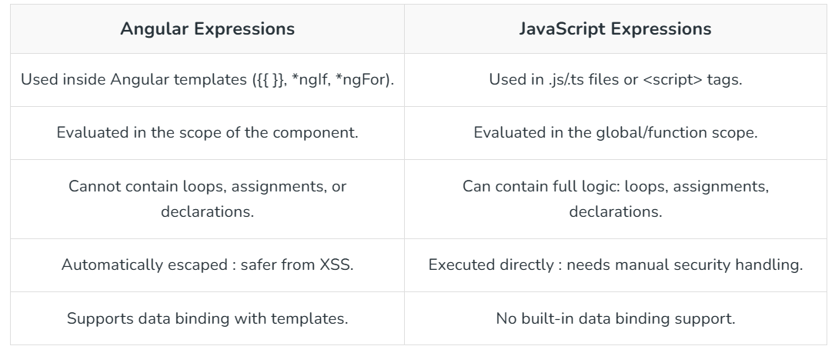
96. What are Single Page Applications (SPA)?
Single Page Applications (SPAs) are web applications that load a single HTML page once and dynamically update the content using JavaScript. This approach enables faster interactions and a smoother, more consistent user experience.
Dynamically updates content without reloading the entire page.
Provides faster performance and a seamless user experience.

97. What are templates in Angular?
A template is a kind of HTML that instructs Angular about how to display a component. An Angular HTML template, like conventional HTML, produces a view, or user interface, in the browser, but with far more capabilities. Angular API evaluates an HTML template of a component, creates HTML, and renders it.
There are two ways to create a template in an Angular component:
Inline Template: The component decorator's template config is used to specify an inline HTML template for a component. The Template will be wrapped inside the single or double quotes.
Linked Template: A component may include an HTML template in a separate HTML file. As illustrated below, the templateUrl option is used to indicate the path of the HTML template file.

98. What is an AOT Compiler?
The AOT (Ahead-of-Time) Compiler in Angular compiles Angular HTML and TypeScript code into efficient JavaScript before the browser downloads and runs the app. This makes the application load faster, reduces runtime errors, and improves overall performance compared to JIT (Just-in-Time) compilation, which happens in the browser.

99.. How many types of compilation Angular provides?
Angular provides two types of compilation:
JIT (Just-in-Time) Compilation:
Happens at runtime in the browser.
Compiles the Angular application in the browser as it loads.
Faster development builds but slower performance in production.
AOT (Ahead-of-Time) Compilation:
Happens during the build phase before the application is run.
Compiles the application into efficient JavaScript code ahead of time, which leads to faster loading and better performance.
Recommended for production builds.

100. What is a component in Angular?
A component is a fundamental building block of Angular applications. It controls a part of the user interface and manages the data and logic for that section. Components are used to create reusable UI elements and define the structure and behavior of the app.
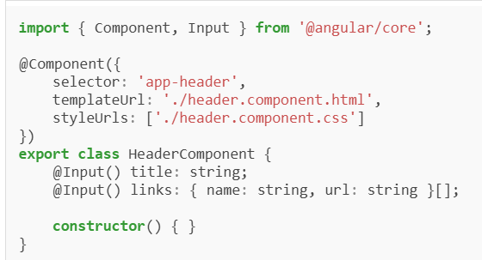

101. Explain the purpose of @Component decorator in Angular?
Defining the Component: It designates a class as an Angular component and provides metadata about the component.
Template Association: Links the component with its HTML template, defining the view.
Style Binding: Associates the component with its CSS styles to encapsulate and manage styling.
Selector Definition: Defines a custom HTML tag (selector) that represents the component in the application.
Dependency Injection Configuration: Specifies the providers for the component, providing dependency injection.

102. What is a module in Angular?
A module is a logical unit of the application that groups related components, directives, pipes, and services. It helps organize and manage the application by encapsulating functionality into cohesive blocks.
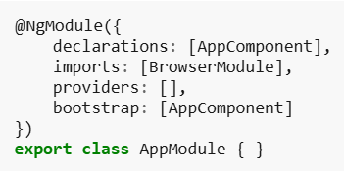

103. What is Angular CLI?
Angular CLI (Command Line Interface) is a powerful tool that helps automate and streamline the development process for Angular applications. It provides a set of commands for creating, managing, and building Angular projects.
Common Angular CLI commands include:
ng new: Creates a new Angular project.
ng serve: Serves the application locally.
ng generate: Generates components, services, and more.
ng build: Builds the application for production.

104. What is a directive in Angular?
Directives are special markers on a DOM element that tell Angular to do something to that DOM element or its children. Directives are used to extend HTML functionality by adding behavior to elements, such as manipulating their attributes or styling.
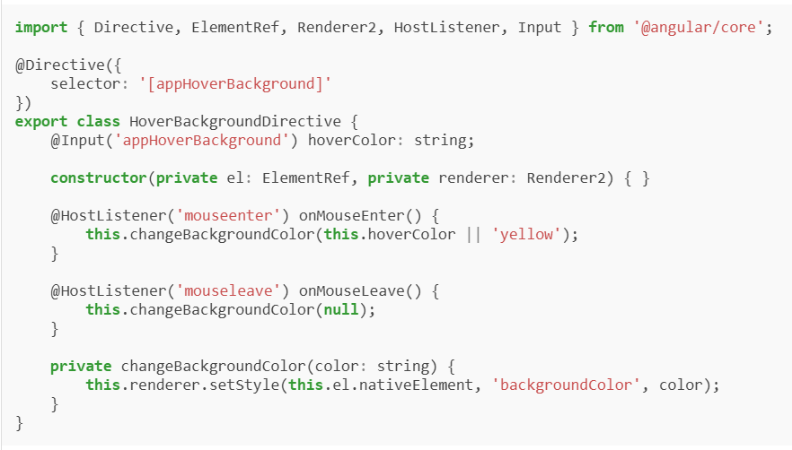

105. What is a service in Angular?
A service is a class that encapsulates reusable logic, which can be shared across different components of an Angular application. Services are typically used for data fetching, business logic, and other operations that need to be shared.
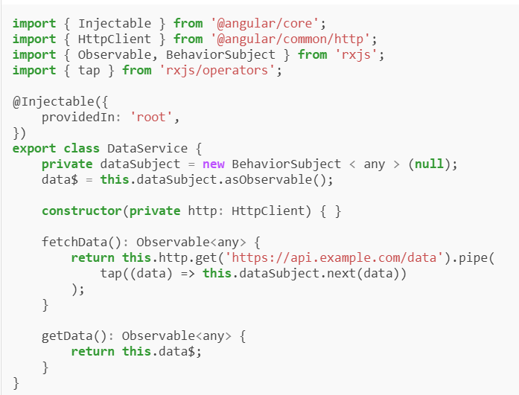

106. Explain two-way data binding in Angular?
Two-way data binding in Angular is a mechanism that allows synchronization of data between the model (component class) and the view (template). It ensures that changes in the model are reflected in the view and vice versa, automatically updating both when either one is modified.
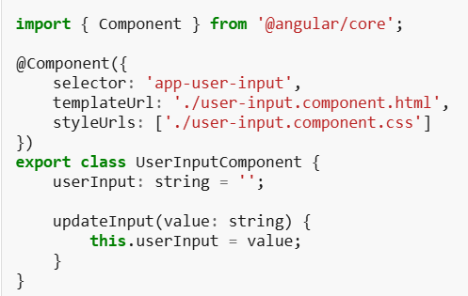

107. What are Angular Lifecycle Hooks?
Angular lifecycle hooks are methods that allow developers to tap into key moments in a component’s lifecycle. Key hooks include ngOnInit (called once when the component is initialized), ngOnChanges (called when input properties change), and ngOnDestroy (called before Angular destroys the component).

108. What is the difference between Angular and AngularJS?
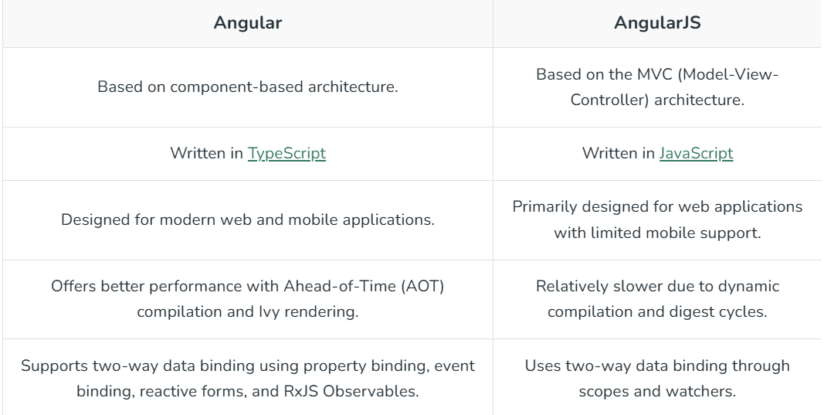

109. What is Data Binding in AngularJS?
Data Binding in Angular provides a function Data Binding which helps us to have an almost real-time reflection of the input given by the user i.e. it creates a connection between Model and View.

110. Differences between one-way binding and two-way binding?
In Angular, both one-way and two-way data binding are supported. Angular provides mechanisms for both types of binding based on the use case.
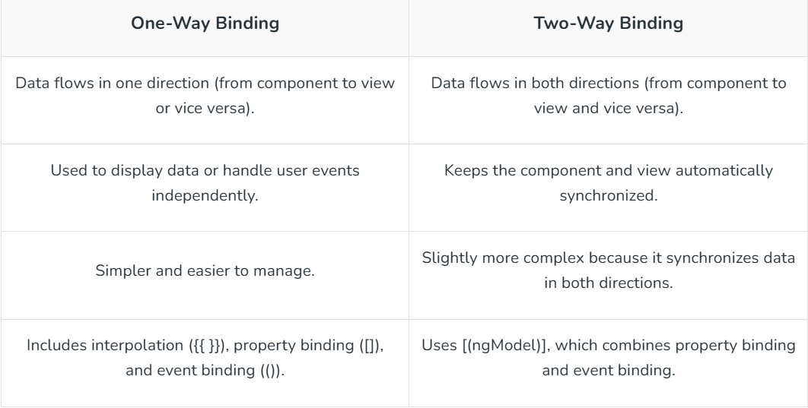

111. What is string interpolation in AngularJS?
String interpolation is a technique used to bind data from the model (JavaScript) to the view (HTML) by embedding expressions within double curly braces {{ }}. It allows you to insert dynamic values or variables into the HTML content, making the view update automatically when the model changes.
<div>{{ message }}</div>

112. How many types of Directives are available in AngularJS?
There are four kinds of directives in AngularJS those are described below:
Element directives
Attribute directives
CSS class directives
Comment directives
113. What is factory method in AngularJS?
- AngularJS Factory Method makes the development process of AngularJS application more robust. A factory is a simple function that allows us to add some logic to a created object and return the created object.
- The factory is also used to create/return a function in the form of reusable code which can be used anywhere within the application.
- Whenever we create an object using a factory it always returns a new instance for that object.
- The object returned by the factory can be integrated(injectible) with different components of the Angularjs framework such as controller, service, filter or directive.

114. What is the digest cycle in AngularJS?
The digest cycle in AngularJS is a process where Angular compares the current and previous values of the scope model to check for changes. If changes are detected, Angular updates the view. This cycle is triggered automatically after an event like a user action, HTTP request, or model change, and it ensures that the view stays in sync with the model. It can also be manually triggered using $apply().

115. What is dependency injection in Angular?
Dependency Injection (DI) in Angular is a design pattern where services or objects are provided to components or other services rather than being created within them. It allows for better modularity, testability, and management of dependencies. Angular's DI framework automatically injects required services into components, making it easier to manage and maintain the application.

116. How do you create a service in Angular?
A service can be created using Angular CLI or manually by creating a class decorated with @Injectable().
Creating a data fetching service.
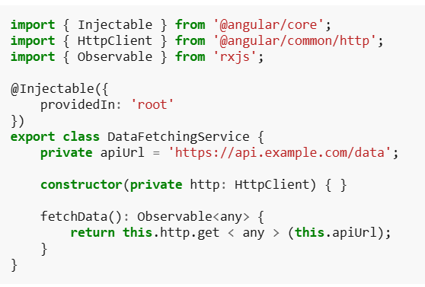

117. What is an Angular router?
The Angular router is a library that enables navigation between different views or pages in a single-page application (SPA). It allows developers to define routes, handle URL changes, and load components dynamically based on the route, providing a smooth and efficient user experience without page reloads.

118. What is scope in Angular?
In Angular, scope refers to the environment or context in which variables, expressions, and functions are evaluated. It determines the visibility and accessibility of these variables within different parts of the application, particularly in relation to the component's template and controller.
Note: In Angular 2+ (modern Angular), the term scope is no longer used. It is replaced by component state and data binding.

119. What type of DOM is used in Angular?
Angular uses the Real DOM (Document Object Model). The Change Detection mechanism is used to update only the affected parts of the DOM when data changes, improving performance. In addition, Angular uses a Shadow DOM for encapsulation, which helps isolate styles and behavior of components.
Real DOM: Updates the entire DOM when changes occur.
Change Detection: Optimizes updates to only parts of the DOM that need re-rendering.
Shadow DOM: Provides component style and behavior encapsulation.

120. In How many ways Bootstrap is embedded in Angular?
In Angular, bootstarp can be implemented by the two ways:
Using npm (Recommended): Install Bootstrap via npm and import it into the angular.json file under the "styles" and "scripts" arrays.
npm install bootstrap
Using CDN (Content Delivery Network): Instead of installing Bootstrap locally, you can link to Bootstrap's CSS and JS files directly from a CDN in your index.html file:
<link rel="stylesheet" href="https://maxcdn.bootstrapcdn.com/bootstrap/4.5.2/css/bootstrap.min.css">
<script src="https://ajax.googleapis.com/ajax/libs/jquery/3.5.1/jquery.min.js"></script>
<script src="https://cdnjs.cloudflare.com/ajax/libs/popper.js/1.16.0/umd/popper.min.js"></script>
<script src="https://maxcdn.bootstrapcdn.com/bootstrap/4.5.2/js/bootstrap.min.js"></script>

121. How can you pass data between components in Angular?
Data can be passed between components using Input and Output decorators, services, or router state.
Passing data from a parent component to a child component using @Input decorator.
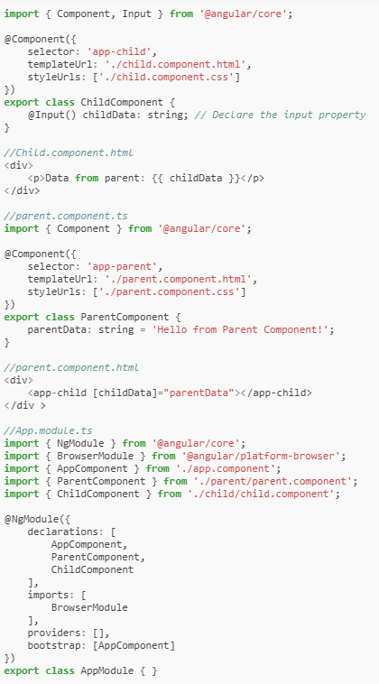

123. Explain lazy loading in Angular?
Lazy loading in Angular is a technique used to improve the performance of an application by loading feature modules only when they are needed, rather than loading all modules upfront. This reduces the initial load time of the application and speeds up the startup process.

124. What is MVVM architecture in Angular?
MVVM (Model-View-ViewModel) is a software architectural pattern that is commonly used in Angular applications, providing a clean separation of concerns between different components of an application. This ensures that changes in one part of the application (like in the logic or data) do not directly affect or interfere with the user interface.
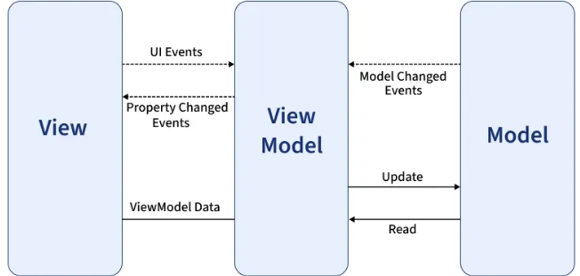
Here's how MVVM works in Angular:

Model:
- Represents the application's data and logic.
- It is the part of the application that manages the state, and it can be composed of services, APIs, or even simple objects.
- In Angular, the Model can be represented by services or interfaces that fetch data from a database or API and expose methods for interacting with that data.
View:
- Represents the UI (user interface) elements that the user interacts with, such as buttons, inputs, forms, etc.
- In Angular, the View is typically defined using HTML and CSS, and it's tied to the template of a component.
- The view listens for changes in the ViewModel and displays updated data to the user.
ViewModel:
- This is the key part of MVVM in Angular. It acts as a bridge between the Model and View.
- The ViewModel holds the data and logic needed to present the Model’s data in a way that the View can easily display.
- It is represented by the component in Angular, which binds the data and defines the behavior that will be reflected in the view.
- Angular’s two-way data binding (via ngModel) allows the ViewModel to automatically synchronize with the View, enabling automatic updates when data changes.

125. What are Angular lifecycle hooks?
Angular lifecycle hooks are methods that allow you to tap into key moments in a component's lifecycle. Here are the main lifecycle hooks:
ngOnInit(): Called once after the component's data-bound properties have been initialized.
ngOnChanges(changes: SimpleChanges): Called whenever one or more data-bound input properties change.
ngDoCheck(): Called during every change detection run, allowing you to implement your own change detection.
ngAfterContentInit(): Called once after Angular projects external content into the component's view.
ngAfterContentChecked(): Called after every check of projected content.
ngAfterViewInit(): Called once after the component's view (and child views) has been initialized.
ngAfterViewChecked(): Called after every check of the component's view (and child views).
ngOnDestroy(): Called just before Angular destroys the component, allowing you to clean up resources.

126. What is a pipe in Angular?
A pipe is a way to transform data in the template. It allows you to format or manipulate data before displaying it to the user. Angular provides several built-in pipes like DatePipe, UpperCasePipe, and CurrencyPipe, and you can also create custom pipes. Pipes are typically used to modify the display of data without altering the original data itself.

127. What is Angular Universal?
Angular Universal is a technology that enables server-side rendering (SSR) for Angular applications, improving performance, initial load times, and search engine optimization (SEO) by pre-rendering the application on the server before sending it to the client. This results in faster, more interactive user experiences and better indexing by search engines.

128. How do you optimize Angular applications?
To optimize Angular applications, you can:
- Use AOT (Ahead-of-Time) Compilation: Pre-compile the application to improve startup time and reduce the size of the bundle.
- Lazy Loading: Load modules only when they are needed to reduce initial loading time.
- OnPush Change Detection: Use the OnPush change detection strategy to minimize unnecessary checks.
- Tree Shaking: Remove unused code during the build process to reduce bundle size.
- Minification and Uglification: Minify and compress JavaScript and CSS files for smaller payloads.
- Use TrackBy with ngFor: Improve performance in lists by using trackBy to avoid re-rendering unchanged items.
- Service Workers: Implement service workers for caching and offline support.

129. What are Angular interceptors?
Angular interceptors are services that intercept and modify HTTP requests and responses. They allow you to perform actions such as adding headers (e.g., authentication tokens), logging, or handling errors globally. Interceptors are useful for managing HTTP communication centrally in Angular applications.

130. Explain the purpose of NgZone in Angular?
NgZone in Angular is a service that helps Angular know when to update the view by tracking asynchronous operations. It runs change detection whenever an asynchronous operation, like a setTimeout or HTTP request, completes. NgZone ensures that Angular is aware of changes in the application state and triggers the necessary updates to the view.

131. What is the difference between @Input() and @Output() in Angular?
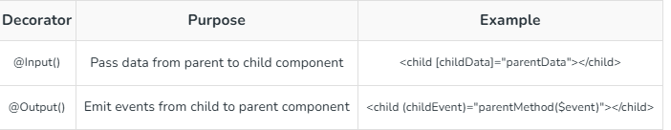

132. How do you implement authentication in Angular?
Authentication can be implemented using JWT tokens, Angular guards, and interceptors to manage login and secure routes.
Securing a route with an AuthGuard.
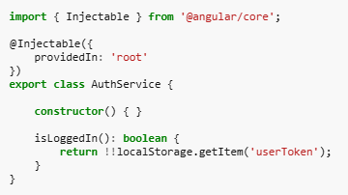
133. What are Standalone Components in Angular 19?
In Angular 19, standalone components provide a simpler and more flexible way to build applications without depending on NgModules. They reduce complexity, improve optimization through better tree-shaking, and make components easier to manage, test, and reuse. This leads to cleaner code, improved performance, and a streamlined development workflow.
No need for complex NgModule dependencies.
Better tree-shaking: Optimized bundle size.
Easier to develop, test, and reuse components independently.
Cleaner code and improved flexibility in application architecture.

134. How do you use Typed Forms?
Typed Forms in Angular 19 provide enhanced type safety for reactive forms. By defining strict types for FormGroup, FormControl, and FormArray, developers can prevent runtime errors, ensure consistency, and handle form data more robustly. This improves maintainability and the overall developer experience.
Strong type-checking for form controls to prevent runtime errors.
Easier management and access to form values with proper type support.
More robust and maintainable reactive forms for large applications.

135. What is the purpose of the Signal API?
The Signal API in Angular simplifies state management by providing reactive signals that automatically track changes and update the view. This reduces the need for manual change detection, improves performance, and makes applications more responsive and efficient.
Automatic tracking of state changes and dependencies.
Updates the view without manual change detection.
Reduces complexity in managing reactivity.
Optimizes performance by minimizing unnecessary updates.

136. How does the inject() function work?
The inject() function simplifies the process of dependency injection (DI). It allows developers to access and inject services or dependencies directly within the component’s constructor or lifecycle methods without the need for constructor injection.

137. What improvements have been made to standalone testing?
Standalone components can now be tested directly, reducing boilerplate code and enhancing tree-shaking by avoiding unnecessary module dependencies. The testing framework has been optimized for better performance and developer experience. Angular 19 also improves integration with testing libraries like Jasmine and Karma, allowing for more straightforward configuration, faster tests, and a smoother testing process.

138. Explain the use of Functional Components?
Functional components focus purely on rendering UI based on inputs and outputs, without requiring a class structure. This approach brings a more functional programming style to Angular, making it easier to write and test components with better performance, especially for simple and reusable components.

139. What is Ahead-of-Time (AOT) compilation in Angular?
Ahead-of-Time (AOT) compilation in Angular is the process of compiling Angular templates and TypeScript code into efficient JavaScript code during the build process, before the application is run in the browser. This reduces the size of the application, improves startup performance, and allows for earlier detection of template errors, resulting in faster rendering and better overall performance in production.

140. What is Ivy in Angular?
Ivy is Angular's next-generation rendering engine, introduced to improve performance and reduce bundle sizes. It offers faster compilation, more efficient rendering, and enhanced debugging capabilities. Ivy's advanced tree-shaking features eliminate unused code, leading to smaller and faster applications. Additionally, Ivy provides better backward compatibility, making it easier to update and maintain Angular applications.

141. Explain the purpose of Angular Elements.
Web Component Integration: Allows Angular components to be packaged as custom elements (web components) that can be used in any HTML page or framework.
Reusability: Enables the reuse of Angular components across different projects and frameworks, providing code sharing and consistency.
Interoperability: Provides the integration of Angular components into non-Angular applications, enhancing flexibility and compatibility.
Encapsulation: Provides encapsulated, self-contained components that encapsulate their logic, styles, and templates, reducing the risk of conflicts in larger applications.

142. What is a Resolver in Angular?
A Resolver in Angular is a service that pre-fetches data before a route is activated, ensuring that the necessary data is available when the route is accessed. This is particularly useful for loading important data that a component depends on, thereby enhancing user experience by avoiding loading indicators or incomplete views.

143. What is difference between Angular and React?
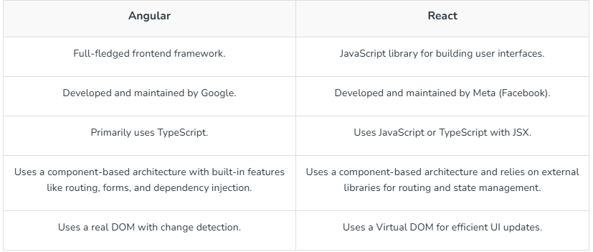

144. How are Angular expressions are different from JavaScript expressions?
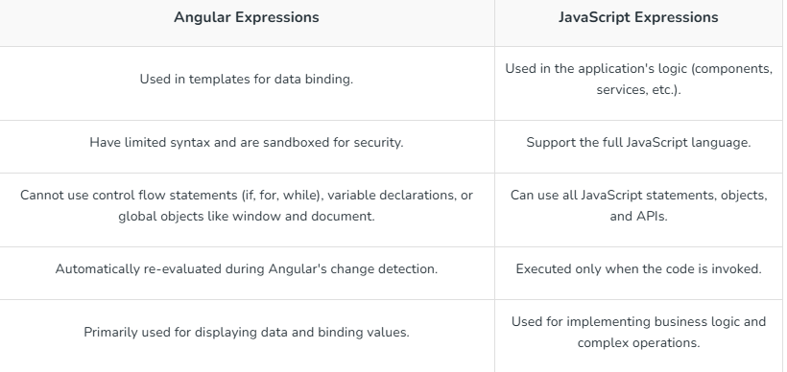
145. What is the purpose of NgModule in Angular?
The purpose of NgModule in Angular is to organize an application into cohesive blocks of functionality by grouping related components, directives, pipes, and services. NgModule defines a compilation context for these elements, providing modularity and maintainability.

146. What is the difference between Template-driven and Reactive Forms?
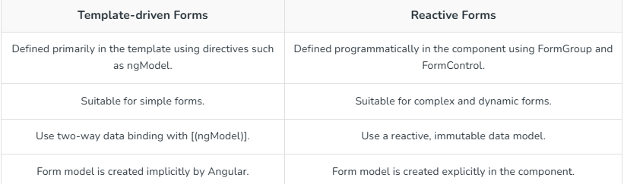

147. What are Angular Guards?
Angular Guards are services that control access to routes in an Angular application. They are used to protect routes from unauthorized access or to prevent unwanted navigation. Common types of guards include:
- CanActivate: Determines if a route can be activated.
- CanDeactivate: Checks if a route can be deactivated.
- CanLoad: Determines if a module can be loaded lazily.

148. How do you create custom validators in Angular?
Custom validators can be created by implementing the ValidatorFn interface and using it in the form controls.
Creating a custom validator to check if a username is available.
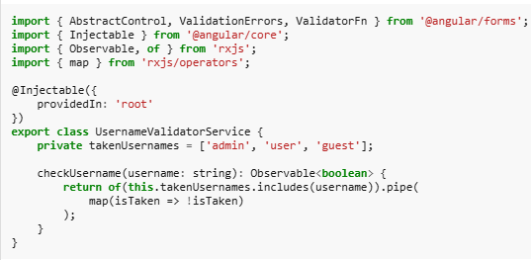

149. What is the purpose of Angular animations?
The purpose of Angular animations is to add dynamic visual effects to applications, improving user experience by making transitions, state changes, and movements more engaging. They enable smooth animations for elements such as fading, sliding, or resizing, triggered by user interactions or state changes in the application.

150. Explain dynamic components in Angular.
Dynamic components in Angular are components that are created and inserted into the application at runtime, rather than being statically declared in the template. This allows for greater flexibility and responsiveness in applications.

151. What is Angular Material?
Angular Material is a UI component library for Angular applications that provides pre-built, reusable, and customizable user interface components, following Google’s Material Design principles. It offers components like buttons, dialogs, form controls, and navigation elements, helping developers create modern, responsive, and visually appealing applications quickly.

152. What is Eager?
In AngularJS, eager loading refers to the process where modules, services, and controllers are loaded at the start of the application, even if they are not immediately needed. Eager loading is typically used when the developer expects all parts of the application to be used early on.

153. What is the purpose of Angular's Renderer2?
- Platform Agnostic: Renderer2 provides a platform-agnostic way to manipulate the DOM, ensuring that the application can run consistently across different environments, such as server-side rendering with Angular Universal or web workers.
- Security: It helps prevent XSS (Cross-Site Scripting) attacks by sanitizing inputs and ensuring safe interactions with the DOM.
- Abstraction: Renderer2 abstracts away direct DOM manipulation, making the code more testable and maintainable by allowing developers to focus on logical rather than low-level DOM operations.
- Consistency: Ensures consistent behavior across various browsers and platforms.

154. What is the difference between AOT and JIT?
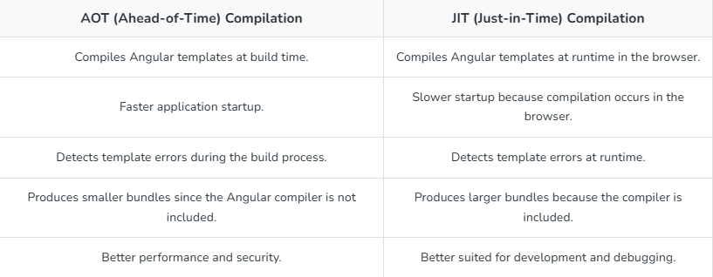

155. What are the benefits of using Web Workers in Angular?
- Improved Performance: Web Workers allow for offloading heavy computations and tasks to background threads, freeing up the main thread and ensuring smoother and more responsive user interfaces.
- Enhanced User Experience: By running complex operations in the background, Web Workers prevent the UI from becoming unresponsive, providing a seamless and uninterrupted user experience.
- Parallel Processing: Web Workers enable parallel processing of tasks, which can significantly speed up operations that are computationally intensive or involve large datasets.
- Better Scalability: Utilizing Web Workers can help scale applications more effectively by distributing the workload, leading to more efficient resource utilization and improved performance under high load conditions.

156. What is Data Binding in Angular?
Data binding in Angular is a mechanism that allows communication between the component and the view (HTML template). It synchronizes the data between the model (component) and the view, making it easy to reflect changes in the UI whenever data changes in the component.
- There are the 4 types of the data binding in Agular:
- Interpolation (One-way Binding)
- Property Binding (One-way Binding)
- Event Binding (One-way Binding)
- Two-way Binding

157. What are impure pipes in angular?
Impure pipes in Angular are pipes that can change the output when input values change over time, even without the change detection running. Unlike pure pipes, impure pipes are evaluated every time change detection runs, which can lead to performance issues if not used carefully.

158. What are pure pipes in angular?
Pure pipes in Angular are pipes that only re-evaluate when their input data changes. This makes them more efficient compared to impure pipes, as they are only executed when the values of the inputs change.

159. What is Pipe transform Interface in Angular?
In Angular, the PipeTransform interface is used to define the structure of a custom pipe. It is part of the Pipe decorator, which helps in creating custom pipes to transform data within templates.

160. We are developing an Angular application that needs to fetch data from multiple APIs and display them together on the same page. How would we handle asynchronous API calls and ensure the data is displayed after all responses are received?
Answer: I would use the RxJS forkJoin operator to handle multiple API calls concurrently. This ensures that all API responses are received before processing the data. Here's how I would implement it:
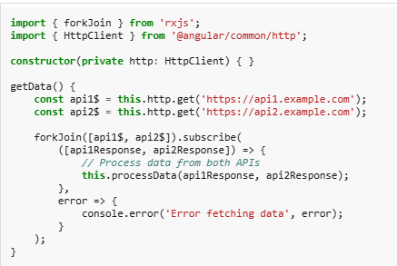
forkJoin waits until all observables complete and then emits the results in an array. This is perfect for scenarios where you want to fetch data from multiple sources simultaneously.

161. Your Angular application is getting slower due to a large number of modules and components. How would you optimize the application’s performance?
Answer: One way to optimize an Angular application is by implementing lazy loading to load modules only when needed. This reduces the initial bundle size, improving load times. Here's an example of setting up lazy loading in Angular:
// app-routing.module.ts
const routes: Routes = [
{ path: 'feature', loadChildren: () => import('./feature/feature.module').then(m => m.FeatureModule) }
];
By using the loadChildren property, Angular will load the FeatureModule only when the user navigates to the /feature route.
This improves the app's performance by deferring the loading of non-essential modules.

162. We have a form where the user enters their email, and we need to ensure that it is both valid and unique (not already in use). How would we implement this validation using Angular Reactive Forms?
Answer: I would use Reactive Forms with custom synchronous and asynchronous validators. Here's how I would implement both email format validation and uniqueness check:
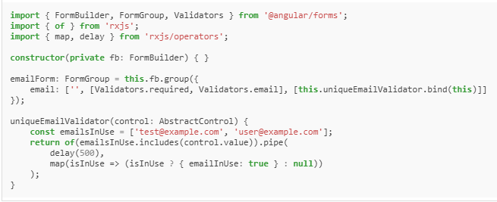
- The Validators.email ensures the entered email is valid, while the uniqueEmailValidator checks asynchronously whether the email is already in use.
- If so, it returns an error, otherwise, it passes validation.

163. We notice that a component is not updating as expected when data changes. How would you debug and resolve the issue related to Angular's change detection mechanism?
Answer: First, I would check if the component is using OnPush change detection strategy:
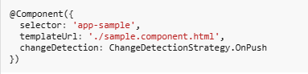
If the OnPush strategy is being used, Angular only checks for changes when an input reference changes. If the data is updated by mutation, Angular will not detect the change. In this case, I would either:
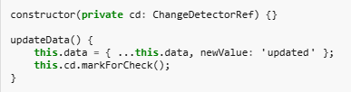
- If the object is mutated directly, OnPush doesn't detect the change.
- Ensure the object reference is changed, or
- Manually trigger change detection using ChangeDetectorRef:
- Creating a new object or using markForCheck ensures that Angular runs change detection.

164. How would you protect specific routes in your Angular application so that only authenticated users can access them?
Answer: I would implement Route Guards using Angular’s CanActivate interface to protect routes. Here's an example of how to implement an authentication guard
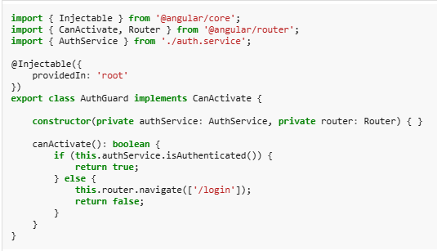
- The AuthGuard checks if the user is authenticated before allowing access to the route.
- If the user is not authenticated, they are redirected to the login page.
- This ensures that only authorized users can access certain parts of the application.

REFER THE BELOW LINK FOR SECNARIO BASED QUESTIONS
SCENARIO BASED QUESTIONS

